Sandford Orcas Village Hall
Children’s Event on Saturday 5th October
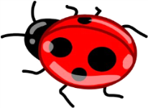
09.30 to 11.30

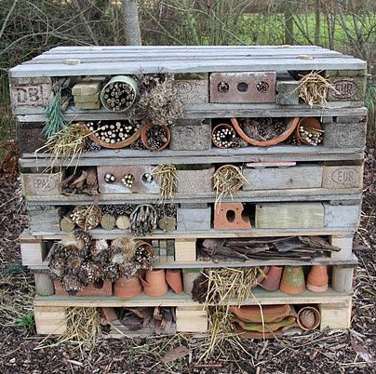
Join us to find out more about some of the minibeasts in our gardens and help us build a bug hotel! Refreshments will be available.
For further information and to reserve a place please contact Sue Yeoman on 07837 812468
Sandford Orcas Village Hall
Children’s Event on Saturday 5th October
9.30 to 11.30

Join us to find out more about some of the minibeasts in our gardens and help us build a bug hotel! Refreshments will be available.
For further information and to reserve a place please contact Sue Yeoman on 07837 812468

