Sandford Orcas Village Hall
Saturday 14th April 7.30pm

Jungle Harmony - Phil & Alex

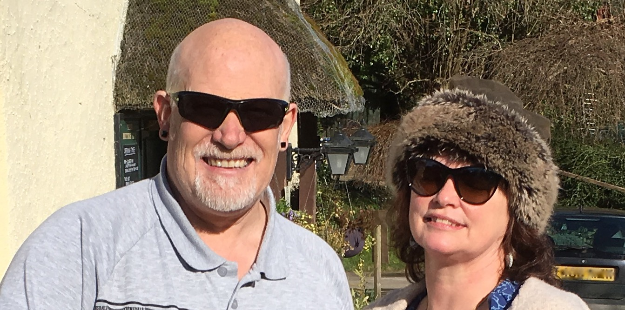

and Secret Chord band– Chris and Phil,
Jayne and Francis, Rhiannon & Yvette
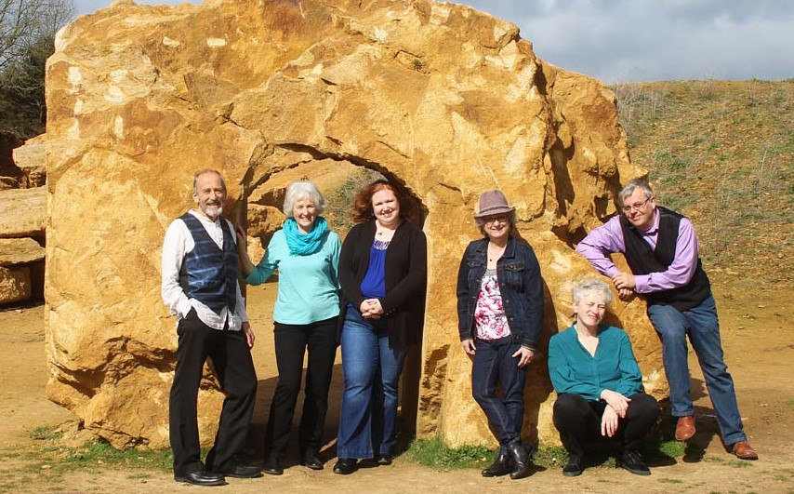

Performance in aid of the Village Hall.
Tickets £6.00 pp (family £15.00)
From Cindy Brown (220521), The Mitre Pub,
Rowlie McBeath (220208), Dan Davies (220749)

