WHAT’S ON
In The Village?
Issue 235 May 2024

Mary and Tom Stewart and Nicky Page successfully ran March’s Village Café. This month it’s Fiona Phillipson’s and Clare Rutter’s turn.

The final Sandford Orcas Film Night showed ‘Operation Mincemeat (2021), based on a true tale of World War 2 deceit and deception in a good cause. Thank you to David and Marjorie Pearson for organising this past winter’s enjoyable Film Nights, and for Tom Stewart and Richard Pollard for their technical expertise.

The annual Village Meeting, on 13th April, saw an excellent turnout. Of the many topics covered, the village’s plans to prevent flooding stood out.

The local government elections will be held on Thursday, 2nd May: it is now a legal requirement that you bring photo ID if you wish to vote. A passport or a photo driving licence are the obvious options, but others are listed at https://www.electoralcommission.org.uk/voting-and-elections/voter-id/accepted-forms-photo-id.

Requests are going out already for us for search our cupboards and attics for pre-loved items that would sell easily at Sandford Orcas’s Summer Fete on Sunday, 30th June at Jerards. The proceeds will go to the church, towards urgent repairs estimated at costing £7,000. The overall repair bill could cost at least £150,000. The more that the Fete can raise the better, before we turn to outside bodies for what will inevitably be the great majority of the financing.

Further ahead still, Sandford Orcas has just signed up for Three Inch Fools theatre company to return on 16th August for the third year to Higher Orchard, courtesy of the Potters. They will present their take on Shakespeare’s ‘Comedy of Errors’ – so watch out for a riotous evening!

CONTACTS / ORGANISERS:
Website: www.sandfordorcasvillagehall.com; Email: info@sovhall.plus.com
Sandford Orcas Village Hall Committee:
Claire Arnold (Fete); Cindy Brown (Secretary); George Lossius (Treasurer, 100 Club);
Rowlie McBeath (QTPC, Artsreach*); Robert Patterson (Billiards & Snooker; PCC);
Rick Pollard (Maintenance, Friends of SOVH); Richard Slade (Chairman).
.* Children’s events are run by Susan Yeoman and Helen Donnelly.

Village (and Outside) Organisers:
FOSOVH Friends of Sandford Orcas Village Hall I.e. anyone who wants to help, on an ad hoc basis
FPO Footpaths Officer Steve Donnelly (01963 220446)
Mitre The Mitre Inn: Steve Hooper (01963 220 271). steve@mitreinn.co.uk
HW Home Watch Allen Page (01963 220 271).
PCC Sandford Orcas PCC: Secretary: Robert Patterson (01963 220 455).
- Dorset Police: Sherborne Rural: PC 2777 Laura McKeeman & PCSO 6269 Mark Jones
Safer Neighbourhood Team Phone: 101, sherborneruralsnt@dorset.pnn.police.uk
QTB Queen Thorne Benefice Rector: Reverend David Bond (01935 850 201)
QTPC Queen Thorne Parish Council Parish Councillors: Jan Lowe (01963 220 490), Rowlie McBeath
(01963 220 208), Paul Phillipson (07974 348545),
Secretary: Rose Edwards (01963 220 491).
www.queenthorneparishcouncil.gov.uk
VH Village Hall: Chairman: Richard Slade (01963 220 740)
Village Hall Bookings: Cindy Brown, sandfordorcasvillagehallsec@gmail.com
Village Events Every Week:
The Mitre Inn Opening Hours: Contact: Steve Hooper (01963 220 271, steve@mitreinn.co.uk) NEW OPENING HOURS!
- Mondays: 6.30 p.m. - 10.30 p.m.
- Tuesdays / Wednesdays: 12.00 p.m. - 3.00 p.m. (Food 12.00 p.m. - 2.00 p.m.) and 6.30 p.m. - 10.30 p.m. (Food 7 p.m. - 9 p.m.)
- Thursdays / Fridays: 5.30 p.m.-6.30 p.m.: HAPPY HOUR! Sandford Orcadians 50p off!
- Thursdays / Fridays / Saturdays: 12.00 p.m. - 3.00 p.m. (Food 12.00 p.m. - 2.00 p.m.) and 5.30 p.m. - 10.30 p.m. (Food 7.00 p.m. - 9.00 p.m.).
- Sundays: 12.00 p.m. - 3.00 p.m. (Food 12.00 p.m. - 2.00 p.m.)
The Story Pig Pop-Up Shop, at Lavender Keepers, in Great Pit Lane:
NEW OPENING HOURS! Thursdays to Sundays 10 a.m. to 2.30 p.m.
Friday Pizza Night: 5.00 p.m. to 8 p.m.
- Open for glorious free range, rare breed Tamworth pork products - bacon rolls, pulled pork, and pork and other products, including Charlotte’s wonderful baked goods! Please pre-order your pizzas on 07724 885 353: the dough is made fresh each day.
- Billiards & Snooker Club: Contact Robert Patterson (01963 220 455) for details.
- Table Tennis Club: Contact Richard Pollard (01963 220 893) for details.
- Bellringing: Contact John Ferdinando (01963 220 666) to learn how to ring church bells.

Thursday, 2nd May 2024. Time: 7.00 a.m. – 10.00 p.m. Sandford Orcas Village Hall
Local Government Elections
These elections are for our Dprset Councillors and Queen Thorne Parish Councillors.
Don’t forget to bring photo ID – it’s now a legal requirement.

Friday, 10th May 2024. Time: 7.30 p.m. Sandford Orcas Village Hall
Miranda Rutter and Rob Harbron present: ‘Bird Tunes’
Fiddle player and composer Miranda Rutter is joined by Rob Harbron on concertina to present ‘Bird Tunes’, an exquisite new suite of folk tunes with birdsong at their core. Mirans has crafted every tune in the project out of fragments of birdsong which she has recorded on her phone during woodland walks near her home. The suite is both a love-song to the intricacy and beauty of birdsong, and a timely reminder of the struggles with habitat loss and human-made dangers faced by migrating birds today. Tickets are available on wegottickets.com/event/614294.

Friday, 10th May 2024. Time: 6.30 p.m. for 7.30 p.m. St. Andrew’s, Trent
Miranda Rutter and Rob Harbron present ‘Bird Tunes’
‘Bird Tunes’ is an exquisite new suite of folk tunes with birdsong at their core, crafted from fragments of recorded woodland birdsong. Tickets from wegottickets.com/event/614294.

Saturday, 11th May 2024. Time: 7.00 p.m. for 7.30 p.m. St. Andrew’s, Trent
‘Organ Extravaganza’
Tickets £10, from Alistair Morgan, 01935 851105 or alistairmorgan51@gmail.com . Drinks in the Rectory from 6.30 p.m. before the concert starts at 7.30.p.m.

Monday, 13th May 2024. Time: 7.30 p.m. Comptons’ Memorial Hall QTPC
Queen Thorne Parish Council
Please come to meet your newly-elected Parish Councillors, and to raise any relevant concerns
that you may have about our villages and county.

Sunday, 30th June 2024. Time: 12.00 noon – 5.00 p.m. Jerards’ Field (DT9 4GH)
Sandford Orcas Summer Fete
All are welcome at Sandford Orcas’s Summer Fete, held at Jerards - follow the arrows - by
kind invitation of the Garton family. This will be the best yet, with a host of attractions and
activities. Reverend David Bond will hold an outdoor service beforehand, at 11.00 a.m.

Published by Sandford Orcas Village Hall Committee. Distributed free to all actual and honorary villagers.
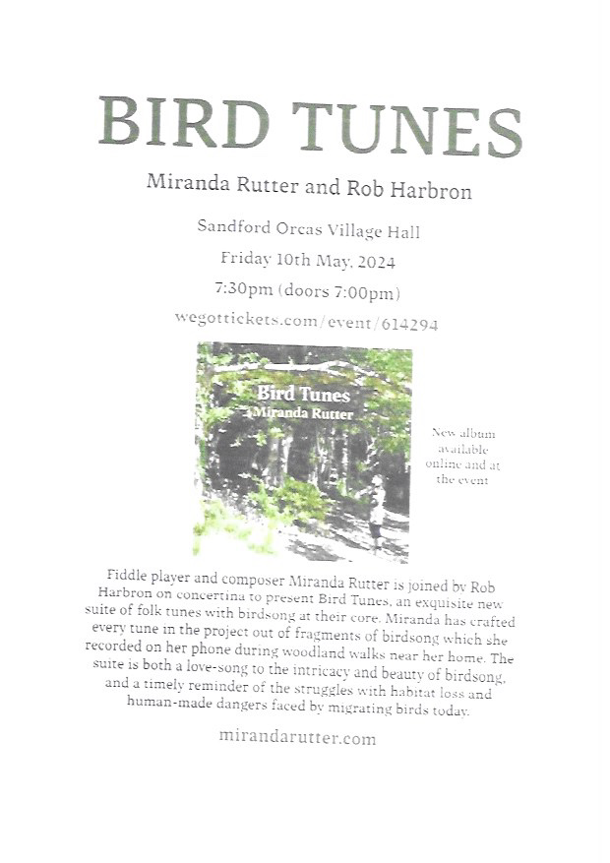
Sandford Orcas Village Community (Version 23).
We have contacted local suppliers who can provide home delivery or collections for basic food and health requirements. Please support, particularly, our most local businesses.

Name & Contact Info | What’s Available – To Buy or To Order | Delivery Options
The Mitre Inn, Sandford Orcas  01963 220 271,  cheryl@mitreinn.co.uk | The menu changes weekly, with locally-sourced produce. Christmas opening hourswill be on www.mitreinn.co.uk. | The pub is open for meals.
Jeff* and Somaya Davies  07918 745826 & 07918 743071  * The Mitre Inn’s chef, no less! | Delicious cakes and bakes: Cakes, Chocolate Logs, Mince Pies, Sausage Rolls, Desserts, Cupcakes and Celebration Cakes. | Contact Jeff and Somaya directly, or through The Mitre Inn (see above).
Glenholme Herbs  Sandford Orcas, 01963 220 302  alison-redman@hotmail.com | Herbs, vegetables and vegetable plants. For the full range, see www.glenholmeherbs.co.uk | Free delivery within Sandford Orcas, or collect. Seasonal plants to order.
The Story Pig  Sandford Orcas, 07802 443 905  jameshull777@gmail.com | Tamworth pork, sausages, bacon, chutney, saffron rolls, apple buns. Also meat boxes. | Now offering pizzas – see above - along with glorious free range, rare breed Tamworth pork products - bacon rolls, pulled pork, and pork and other products. Please pre-order your pizzas on 07724 885 353: the dough is made fresh each day.
Rosanne Eskell  Higher Sandford House,  Sandford Orcas, 01963 220 275  r.eskell@hotmail.com | Sandford Orcas’ very own ‘Benchy View’ white wine, grown in Rosanne’s own vineyard. Rated “delicious” by our ex- wine merchant Rector! | Free delivery in Sandford Orcas, discuss delivery elsewhere with Rosanne when ordering.
Kim Creswell, Dip.Herb.Med.,MNIMH  By The Ford, Moorway Lane,  Sandford Orcas, 07765 654 771  www.kimcreswell.co.uk  kim@kimcreswell.co.uk  www.goldberryherbs.co.uk  kim@goldberryherbs.co.uk | Fully qualified and insured medical herbalist, trained in diagnosis, treatment and medicine making, using organically grown medicinal herbs.  Woven willow sculptures and baskets.  Willow weaving courses. | Professional, confidential and able to prescribe alongside conventional health care. Also grower of willow, maker of sculptures, baskets and other rural crafts. Workshops held and private bookings available.
Fiona Potter, Higher Orchard,  Sandford Orcas.  01963 220 773, 07708 842 553  fionapotter@live.co.uk | Bramblewood grass fed Dexter Beef. Joints, steaks, stewing steak, mince, sausages and burgers. Also Pure Apple Juice from their own trees. | Current beef stocks have expired for now – you’ve bought it all! Fiona’s apple juice remains available, and is on sale at The Story Pig.
Monique Hustinx.  07949-595632  monique.hustinx@hotmail.com | Sandford Orcas-reared, lamb. Half a Lamb: £80, Quarter of a Lamb: £40. Butchered to your requirements. | Contact Monique for delivery details.  www.ciderappletrees.co.uk
Market Town Garden  52, Cheap Street, Sherborne  07967 659638  sherbornemarketfruitandveg@aol.com | Fresh fruit and vegetables. | Contact them, or visit their shop, to discuss box sizes and delivery details.
J&M Parsons  Cheap Street, Sherborne  01935 812 071  info@parsonsbutchers.co.uk | Traditional butcher and milk, cheese, eggs. | Free delivery with orders over £10.
Olives Et Al  Sturminster Newton  01283 474 300  viki@olivesetal.co.uk | Fresh fruit, vegetables, freshly-made bread, milk, eggs, pasta, rice, biscuits, chocolate and all your Olives et Al favourites. | Free delivery to village through Viki (East Field Cottage). Viki also collects shopping & medical prescriptions.

Useful Facebook groups: Queen Thorne Parish News and Views; Sherborne Viral Kindness

