WHAT’S ON
In The Village?
Issue 241 November 2024

Roger and Cindy Brown ran Octoiber’s Village Café most successfully. This month, it’s the turn of Janet and Michael Towers and Mary Stewart. All are welcome!

October was a busy month in the village:
- on 13th October, thanks to Artsreach, a select audience was delighted by VRï, a Welsh folk trio whose musicianship was enhanced by their singing in Welsh.
- on 18th October the Film Night showed ‘Intouchables’, a French buddy comedy-drama based on the true story of a wheelchair-bound aristocrat and his French-Algerian carer.
- on 19th October the Mitre Inn hosted a Reggae Night.
- 26th October was Quiz Night at the Mitre. The next Quiz Night is on 24th November.
- lastly, on 29th October, the Village Hall was packed for the fascinating talk ‘Bombs Over Sherborne’, which told how Sherborne was bombed in May 1940 thanks to faulty navigation. Including donations, £1005 was raised towards refurbishment of our church.
Thank you to everyone who organised these activities: our village community life benefitted.

The Village Hall Committee needs new blood, both on the Committee and to help to run events. These events don’t magically happen by themselves. Our village community is known locally as lively, vibrant and involving; if you wish it to stay that way, please volunteer yourself to a Committee member for any role you like, and you will be made most welcome.

The Mitre Inn has a new chef (Mike) and a new menu. Be sure to try them out!

Too much is happening overleaf to fit it in there, but Award-winning quintet ‘Alvorada’ are performing in Nether Compton Memorial Hall on 30th November. See the attached poster.

CONTACTS / ORGANISERS:
Website: www.sandfordorcasvillagehall.com; Email: info@sovhall.plus.com
Sandford Orcas Village Hall Committee:
Claire Arnold (Fete); Cindy Brown (Secretary); George Lossius (Treasurer, 100 Club);
Rowlie McBeath (QTPC, Artsreach*); Robert Patterson (Billiards & Snooker; PCC);
Richard Pollard (Maintenance, Friends of SOVH); Richard Slade (Chairman).
.* Children’s events are run by Susan Yeoman and Helen Donnelly.

Village (and Outside) Organisers:
FOSOVH Friends of Sandford Orcas Village Hall I.e. anyone who wants to help, on an ad hoc basis
FPO Footpaths Officer Steve Donnelly (01963 220446)
Mitre The Mitre Inn: Steve Hooper (01963 220 271). steve@mitreinn.co.uk
HW Home Watch Allen Page (01963 220 271).
PCC Sandford Orcas PCC: Secretary: Nickie Page (07766 666552‬).‬‬‬‬‬‬‬‬‬‬‬‬‬‬‬‬‬‬‬‬‬‬‬‬‬‬‬‬‬‬‬‬‬‬‬‬‬‬‬‬‬‬‬
- Dorset Police: Sherborne Rural: PC 2777 Laura McKeeman & PCSO 6269 Mark Jones
Safer Neighbourhood Team Phone: 101, sherborneruralsnt@dorset.pnn.police.uk
QTB Queen Thorne Benefice Rector: Reverend David Bond (01935 850 201)
QTPC Queen Thorne Parish Council Parish Councillors: Jan Lowe (01963 220 490), Rowlie McBeath
(01963 220 208), Paul Phillipson (07974 348545),
Secretary: Rose Edwards (01963 220 491).
www.queenthorneparishcouncil.gov.uk
VH Village Hall: Chairman: Richard Slade (01963 220 740)
Village Hall Bookings: Cindy Brown, sandfordorcasvillagehallsec@gmail.com
Village Events Every Week:
- The Mitre Inn Opening Hours: Contact: Steve Hooper (01963 220 271, steve@mitreinn.co.uk) NEW WINTER OPENING HOURS
- Monday CLOSED. Christmas Menu available from 1st to 22nd December.
- Tuesday 6 p.m. - 10.30 p.m. (Simple Casserole / Curry from 6.30 p.m. - 8.30 p.m.).
- Wed / Thurs / Fri Sat 12.00 noon - 3 p.m. & 6 p.m. - 10.30 p.m. (Food served 12 noon - 2 p.m. & 6.30 p.m. - 8.30 p.m.).
- Sunday 12 noon - 4 p.m. (Two food sittings, 12 noon - 2 p.m. & 2.30 p.m. - 4 p.m.).
The Mitre will be CLOSED for a private event from 5:30 p.m. on Saturday, 2nd November.
- The Story Pig Pop-Up Shop, at Lavender Keepers, in Great Pit Lane:
Open for glorious free range, pork products - bacon rolls, pulled pork and other pork products - lavender products and Charlotte’s wonderful baked goods!
- Pizza Night* on Fridays 5 p.m. - 8 p.m. ) NEW OPENING
- Saturdays and Sundays 10 a.m. - 3 p.m. ) HOURS
* Pizzas must be pre-ordered on 07724 885 353: the dough is made fresh each day.
- Billiards & Snooker Club: Contact Robert Patterson (01963 220 455) for details.
- Table Tennis Club: Contact Richard Pollard (01963 220 893) for details.
- Bellringing: Contact John Ferdinando (01963 220 666) to learn how to ring church bells.

Saturday, 9th November 2024. Time: 10.30 a.m. – 11.30 a.m. Village Hall SOVH
Village Café
The Village Café is a great way to catch up with local news. All proceeds go to the Village Hall. All helpers welcome - please contact Maggie Pollard. (maggiepollarde@gmail.com).

Saturday, 9th November 2024. Time: 11.30 a.m. Village Hall SOVH
Sandford Orcas Village Hall Annual General Meeting
Please come to this important meeting, to learn about the past year’s achievements, and to influence what will happen in the Hall this coming year. The Village Hall belongs to all of us; it is important that we all use it and make the most of what it offers our village community.

Saturday, 9th November 2024. Time: 8.00 p.m. Mitre Inn Mitre
Bonfire Night at the Mitre
Fish & Chips! Live music with Peter Burns. Tickets: £10 per person, or family ticket (3 or more) £25. Please see the attached poster, and please park cars in the Village Hall car park.

Friday, 15th November 2024. Time: 7.00 p.m. Village Hall SOVH
Rob Barrett – Comedian, Musician, Satirist!
Rob Barratt is a Dudley-born, Cornwall-based comic poet, humourist and singer. His brain-tickling, word-mangling performance combines clever word play, verse and song with satire, parody and audience participation. He covers such important topics as second homes, squid, distressed furniture, data-driven education, Neanderthal politics and his relationship with potatoes, but beneath the humour serious issues lurk. Please see the attached poster.

Friday, 22nd November 2024. Time: 7.00 p.m. for 7.30 p.m. Village Hall SOVH
Film Night: ‘The Kite Runner’ (2007) (12)
Growing up in Kabul, Amir and Hassan are inseparable friends. As an adult living in California, Amir remains haunted by a childhood incident in which he betrayed Hassan’s trust. When he learns that the Taliban has murdered Hassan and his wife, Amir returns to his homeland to learn the fate of the couple’s son. A beautiful, poignant and very moving film.

Saturday, 23rd November 2024. Time: 11.00 a.m. – 3.30 p.m. CD’s Village Hall
Corton Denham Christmas Fair Please see the attached poster.

Sunday, 24th November 2024. Time: 7.00 p.m. Mitre Inn Mitre
Quiz Night at The Mitre

Published by Sandford Orcas Village Hall Committee. Distributed free to all actual and honorary villagers.

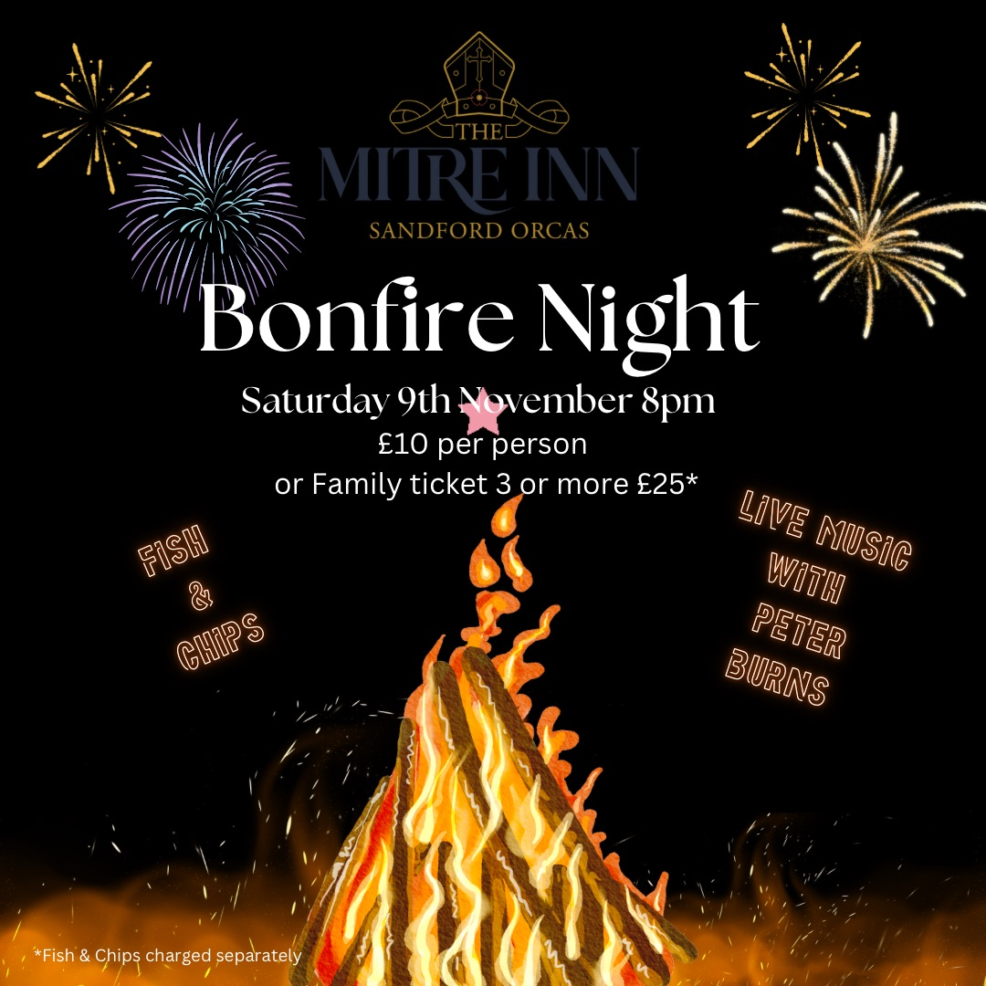

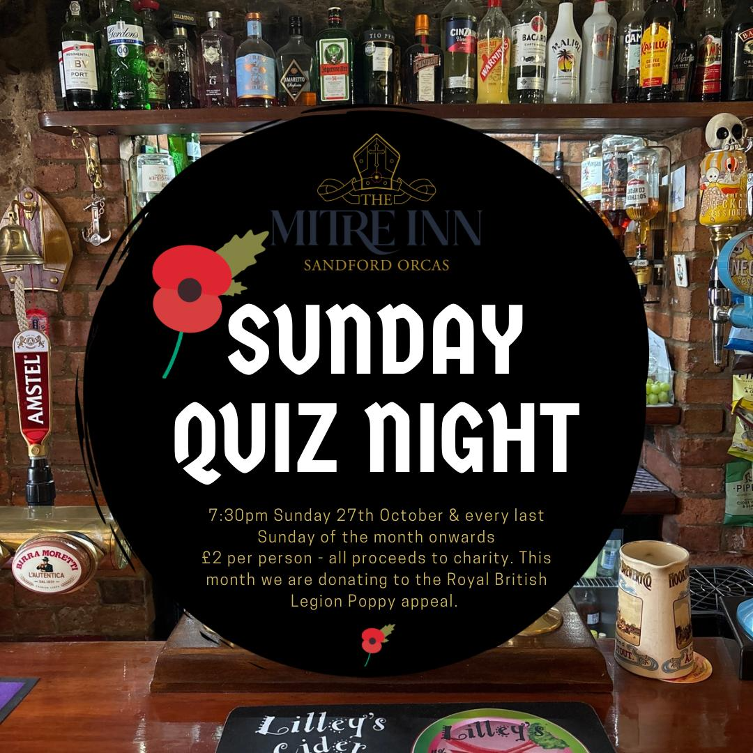


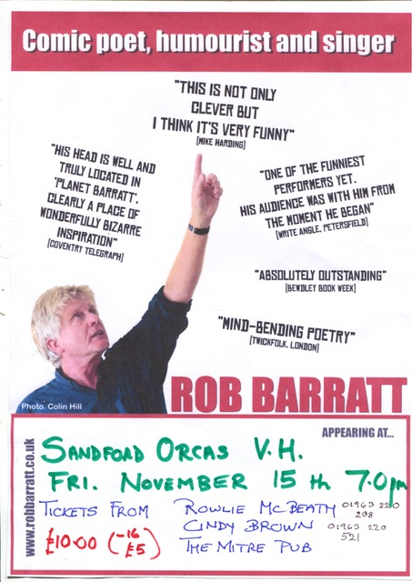

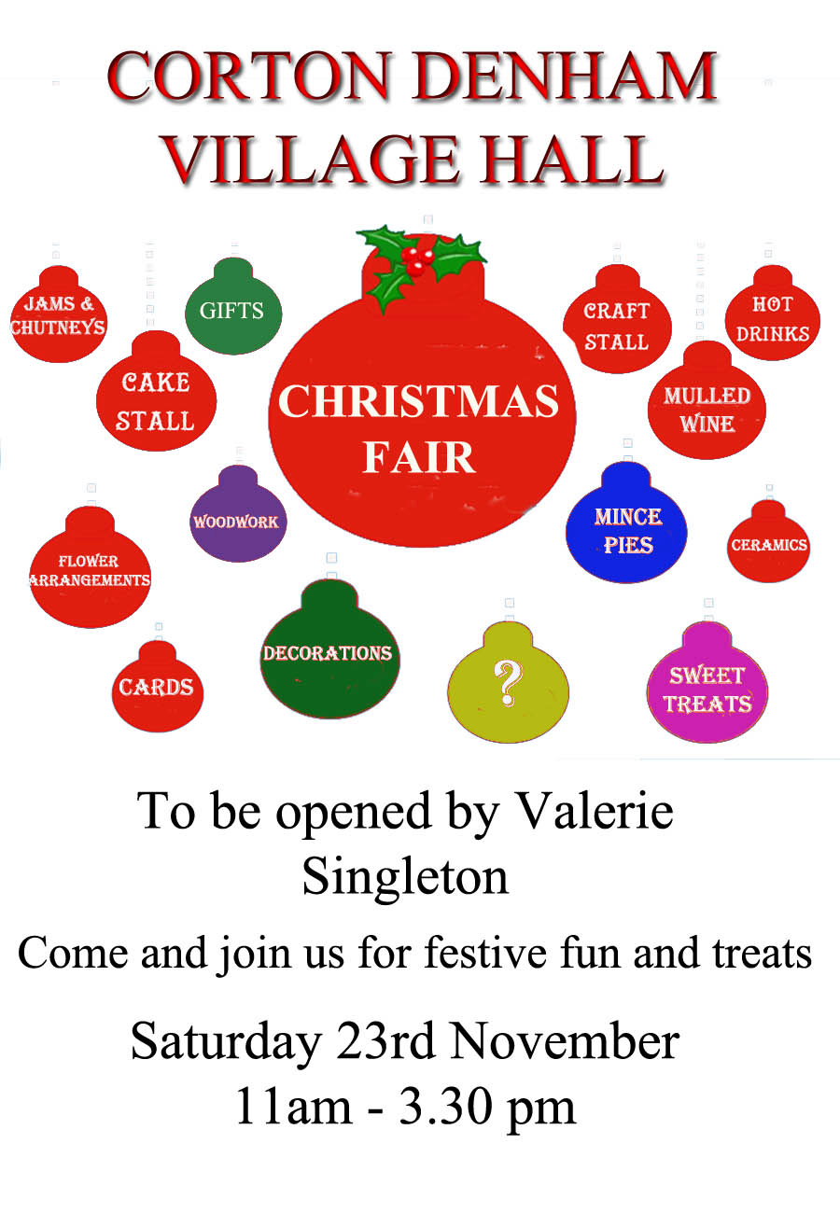

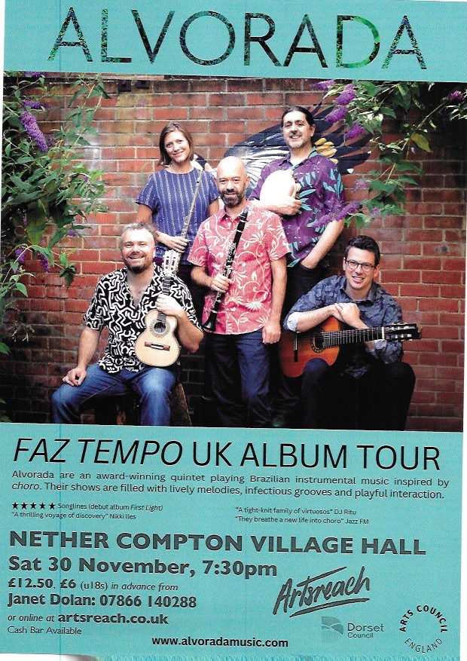

Sandford Orcas Village Community (Version 24).
Here are local suppliers who can provide home delivery or collections for basic food and health requirements. Please support, particularly, our most local businesses.

Name & Contact Info | What’s Available – To Buy or To Order | Delivery Options
The Mitre Inn, Sandford Orcas  01963 220 271, steve@mitreinn.co.uk | The menu changes weekly, with locally-sourced produce. Opening hours will be on www.mitreinn.co.uk. | The pub is open for meals.
Glenholme Herbs  Sandford Orcas, 01963 220 302  alison-redman@hotmail.com | Herbs, vegetables and vegetable plants. For the full range, see www.glenholmeherbs.co.uk | Free delivery within Sandford Orcas, or collect. Seasonal plants to order.
The Story Pig  Sandford Orcas, 07802 443 905  jameshull777@gmail.com | Tamworth pork, sausages, bacon, chutney, saffron rolls, apple buns. Also meat boxes. | Now offering pizzas – see above - along with glorious free range, rare breed Tamworth pork products - bacon rolls, pulled pork, and pork and other products. Please pre-order your pizzas on 07724 885 353: the dough is made fresh each day.
Rosanne Eskell  Higher Sandford House,  Sandford Orcas, 01963 220 275  r.eskell@hotmail.com | Sandford Orcas’ very own ‘Benchy View’ white wine, grown in Rosanne’s own vineyard. Rated “delicious” by our ex- wine merchant Rector! | Free delivery in Sandford Orcas, discuss delivery elsewhere with Rosanne when ordering.
Kim Creswell, Dip.Herb.Med.,MNIMH  By The Ford, Moorway Lane,  Sandford Orcas, 07765 654 771  www.kimcreswell.co.uk  kim@kimcreswell.co.uk  www.goldberryherbs.co.uk  kim@goldberryherbs.co.uk | Fully qualified and insured medical herbalist, trained in diagnosis, treatment and medicine making, using organically grown medicinal herbs.  Woven willow sculptures and baskets.  Willow weaving courses. | Professional, confidential and able to prescribe alongside conventional health care. Also grower of willow, maker of sculptures, baskets and other rural crafts. Workshops held and private bookings available.
Fiona Potter, Higher Orchard,  Sandford Orcas.  01963 220 773, 07708 842 553  fionapotter@live.co.uk | Bramblewood grass fed Dexter Beef. Joints, steaks, stewing steak, mince, sausages and burgers. Also Pure Apple Juice from their own trees. | Current beef stocks have expired for now – you’ve bought it all! Fiona’s apple juice remains available, and is on sale at The Story Pig.
Monique Hustinx.  07949-595632  monique.hustinx@hotmail.com | Sandford Orcas-reared, lamb. Half a Lamb: £80, Quarter of a Lamb: £40. Butchered to your requirements. | Contact Monique for delivery details.  www.ciderappletrees.co.uk
Market Town Garden  52, Cheap Street, Sherborne  07967 659638  sherbornemarketfruitandveg@aol.com | Fresh fruit and vegetables. | Contact them, or visit their shop, to discuss box sizes and delivery details.
J&M Parsons  Cheap Street, Sherborne  01935 812 071  info@parsonsbutchers.co.uk | Traditional butcher and milk, cheese, eggs. | Free delivery with orders over £10.

Useful Facebook groups: Queen Thorne Parish News and Views; Sherborne Viral Kindness

