WHAT’S ON
In The Village?
Issue 237 July 2024

This issue is slightly delayed to allow the inclusion of comment on Sandford Orcas’s Summer Fete, held on 30th June. It was a tremendous success, really enjoyable, with a brand-new venue and Fete Committee, and a record sum raised. Particular thanks must go to Rupert and Alice Garton, for making Jerards available for the Fete. The space available, the ease of access and the views were transformative, but the behind-the-scenes investment in time, effort and infrastructure by them both were remarkable. Thank you! Equally to be thanked are the Fete Committee team, led by Claire Arnold and Gareth Lewis, who spent unimaginable amounts of time conceiving and tweaking plans and putting everything in place. Thank you as well! And all that only a few weeks after hosting Claire’s son’s wedding! What a joyful open-air Songs of Praise service we enjoyed at the Fete site beforehand!

Joanna, Patrick and Maggie ran June’s Village Café successfully. This month it’s Steve’s and Viv’s turn. Delicious ice cream left over from the Fete will be available to buy at a good price!

Artsreach have two events for us to look forward to in August:
On 16th August, Three Inch Fools present ‘The Comedy of Errors’, Shakespeare’s shortest - and wildest - comedy in the open air at Higher Orchard, courtesy of the Potter family. The clock is ticking, as the Fools rush to untangle one almighty mess in this farcical tale of long-lost twins, hysterical misunderstandings, and endless mishaps;
On 21st August, Kevin Burke invites children of age 5+ to run off to the circus and learn new ‘Circus Skills’. Join Kevin and learn a variety of circus skills including juggling with clubs, rings, balls and scarves, diabolo, plate spinning, stilts, poi and rolla bolla!
Tickets are available on line from Ticketsource, or from Susan Yeoman or Helen Donnelly.

CONTACTS / ORGANISERS:
Website: www.sandfordorcasvillagehall.com; Email: info@sovhall.plus.com
Sandford Orcas Village Hall Committee:
Claire Arnold (Fete); Cindy Brown (Secretary); George Lossius (Treasurer, 100 Club);
Rowlie McBeath (QTPC, Artsreach*); Robert Patterson (Billiards & Snooker; PCC);
Rick Pollard (Maintenance, Friends of SOVH); Richard Slade (Chairman).
.* Children’s events are run by Susan Yeoman and Helen Donnelly.

Village (and Outside) Organisers:
FOSOVH Friends of Sandford Orcas Village Hall I.e. anyone who wants to help, on an ad hoc basis
FPO Footpaths Officer Steve Donnelly (01963 220446)
Mitre The Mitre Inn: Steve Hooper (01963 220 271). steve@mitreinn.co.uk
HW Home Watch Allen Page (01963 220 271).
PCC Sandford Orcas PCC: Secretary: Nickie Page (07766 666552‬).‬‬
- Dorset Police: Sherborne Rural: PC 2777 Laura McKeeman & PCSO 6269 Mark Jones
Safer Neighbourhood Team Phone: 101, sherborneruralsnt@dorset.pnn.police.uk
QTB Queen Thorne Benefice Rector: Reverend David Bond (01935 850 201)
QTPC Queen Thorne Parish Council Parish Councillors: Jan Lowe (01963 220 490), Rowlie McBeath
(01963 220 208), Paul Phillipson (07974 348545),
Secretary: Rose Edwards (01963 220 491).
www.queenthorneparishcouncil.gov.uk
VH Village Hall: Chairman: Richard Slade (01963 220 740)
Village Hall Bookings: Cindy Brown, sandfordorcasvillagehallsec@gmail.com
Village Events Every Week:
The Mitre Inn Opening Hours: Contact: Steve Hooper (01963 220 271) steve@mitreinn.co.uk)
- Mondays: 6.30 p.m. - 10.30 p.m.
- Tuesdays / Wednesdays: 12.00 p.m. - 3.00 p.m. (Food 12.00 p.m. - 2.00 p.m.) and 6.30 p.m. - 10.30 p.m. (Food 7 p.m. - 9 p.m.)
- Thursdays / Fridays: 5.30 p.m.-6.30 p.m.: HAPPY HOUR! Sandford Orcadians 50p off!
- Thursdays / Fridays / Saturdays: 12.00 p.m. - 3.00 p.m. (Food 12.00 p.m. - 2.00 p.m.) and 5.30 p.m. - 10.30 p.m. (Food 7.00 p.m. - 9.00 p.m.).
- Sundays: 12.00 p.m. - 3.00 p.m. (Food 12.00 p.m. - 2.00 p.m.)
The Story Pig Pop-Up Shop, at Lavender Keepers, in Great Pit Lane:
NEW OPENING HOURS! Thursdays to Sundays 10 a.m. to 2.30 p.m.
Friday and Saturday Pizza Nights: 5.00 p.m. to 8 p.m.
- Open for glorious free range, pork products - bacon rolls, pulled pork, and pork and other products, including Charlotte’s wonderful baked goods! Please pre-order your pizzas on 07724 885 353: the dough is made fresh each day.
- Billiards & Snooker Club: Contact Robert Patterson (01963 220 455) for details.
- Table Tennis Club: Contact Richard Pollard (01963 220 893) for details.
- Bellringing: Contact John Ferdinando (01963 220 666) to learn how to ring church bells.

Monday, 1st July 2024. Time: 7.30 p.m. Sandford Orcas Village Hall QTPC
Queen Thorne Parish Council
Your Parish Councillors: Jan Lowe (01963 220 490); Rowlie McBeath (01963 220 208), Paul
Phillipson (07974348545). Please come, to raise any relevant concerns that you have.

Thursday, 4th July 2024. Time: 7.00 a.m. – 10.00 p.m. Village Hall
General Election
Every vote counts, so please use yours. Remember to bring photo ID.

Saturday, 6th July 2024. Time: 2.00 p.m. onwards Nether Compton Village Green
Comptons’ Fete and Sheep Racing
All the usual fun of the fair, featuring live music, sheep racing, tug of war, a fun dog show …

Saturday, 6th July 2024. Time: 8.00 p.m. - 10.30 p.m. Mitre Inn Mitre
Vintage Reggae Night and Dancing!

Saturday, 3rd August 2024. Time: 2.00 p.m. - 8.00 p.m. Mitre Inn Mitre
Antiques Roadshow!
Once again, the Mitre Inn is hosting an Antiques Roadshow, featuring TV’s Gordon Brockman. Bring your antiques along to be valued … Please contact Steve Hooper on 01963 220 271 or steve@mitreinn.co.uk for details.

Friday, 16th August 2024. Time: 7.00 p.m. Higher Orchard Artsreach
Three Inch Fools present ‘The Comedy of Errors’

The Three Inch Fools are back with Shakespeare's shortest (and wildest) comedy farcical tale of long-lost twins, hysterical misunderstandings, and endless mishaps.

Tickets: £16 adults, £5 under 18s and £40 families (max 2 adults) from www.artsreach.co.uk,

Wednesday, 21st August 2024. Time: 2.00 p.m. - 4.00 p.m. Village Hall Artsreach
Kevin Burke presents ‘Circus Skills’
Run off to the circus this summer and learn new skills that will impress your friends and family!

Friday, 23rd August 2024. Time: 9.00 p.m. - 11.00 p.m. Mitre Inn Mitre
Live Music: Peter Burns – Rock & Soul!

Published by Sandford Orcas Village Hall Committee. Distributed free to all actual and honorary villagers.

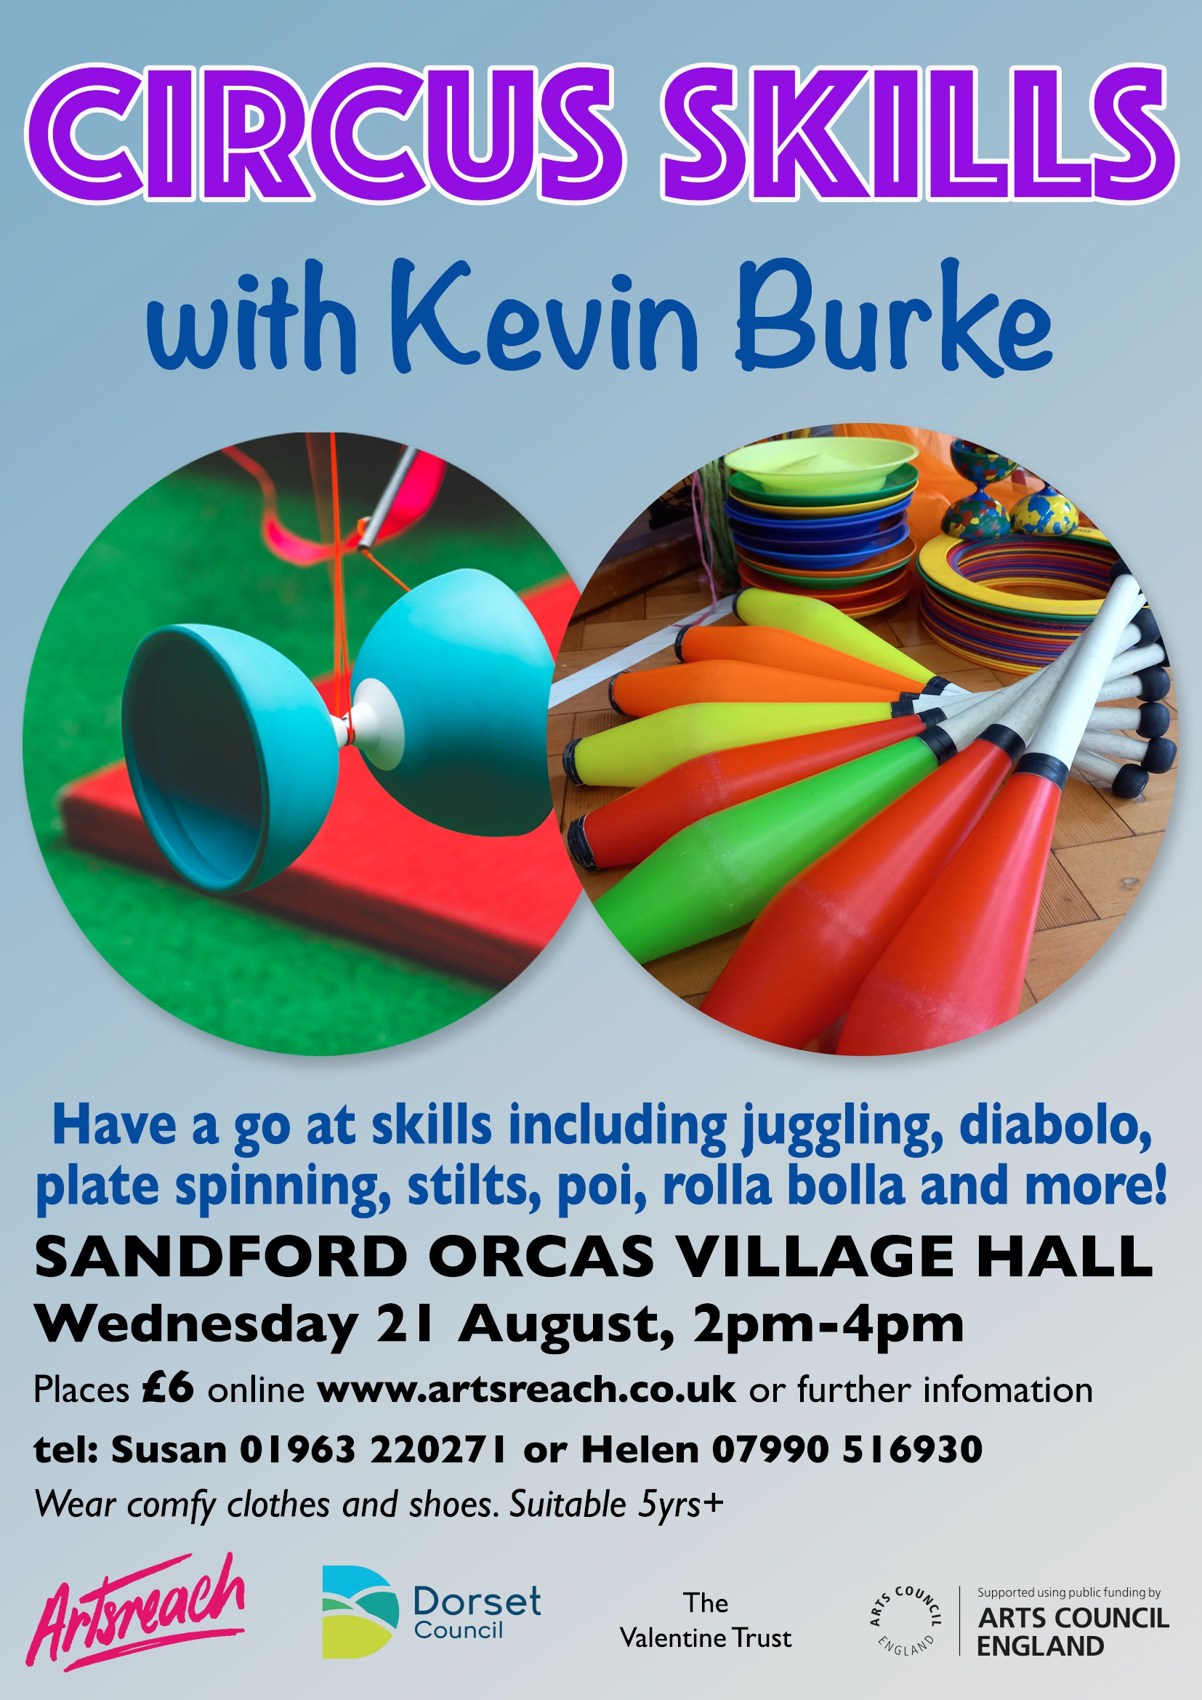
Sandford Orcas Village Community (Version 23).
We have contacted local suppliers who can provide home delivery or collections for basic food and health requirements. Please support, particularly, our most local businesses.

Name & Contact Info | What’s Available – To Buy or To Order | Delivery Options
The Mitre Inn, Sandford Orcas  01963 220 271,  cheryl@mitreinn.co.uk | The menu changes weekly, with locally-sourced produce. Christmas opening hourswill be on www.mitreinn.co.uk. | The pub is open for meals.
Jeff* and Somaya Davies  07918 745826 & 07918 743071  * The Mitre Inn’s chef, no less! | Delicious cakes and bakes: Cakes, Chocolate Logs, Mince Pies, Sausage Rolls, Desserts, Cupcakes and Celebration Cakes. | Contact Jeff and Somaya directly, or through The Mitre Inn (see above).
Glenholme Herbs  Sandford Orcas, 01963 220 302  alison-redman@hotmail.com | Herbs, vegetables and vegetable plants. For the full range, see www.glenholmeherbs.co.uk | Free delivery within Sandford Orcas, or collect. Seasonal plants to order.
The Story Pig  Sandford Orcas, 07802 443 905  jameshull777@gmail.com | Tamworth pork, sausages, bacon, chutney, saffron rolls, apple buns. Also meat boxes. | Now offering pizzas – see above - along with glorious free range, rare breed Tamworth pork products - bacon rolls, pulled pork, and pork and other products. Please pre-order your pizzas on 07724 885 353: the dough is made fresh each day.
Rosanne Eskell  Higher Sandford House,  Sandford Orcas, 01963 220 275  r.eskell@hotmail.com | Sandford Orcas’ very own ‘Benchy View’ white wine, grown in Rosanne’s own vineyard. Rated “delicious” by our ex- wine merchant Rector! | Free delivery in Sandford Orcas, discuss delivery elsewhere with Rosanne when ordering.
Kim Creswell, Dip.Herb.Med.,MNIMH  By The Ford, Moorway Lane,  Sandford Orcas, 07765 654 771  www.kimcreswell.co.uk  kim@kimcreswell.co.uk  www.goldberryherbs.co.uk  kim@goldberryherbs.co.uk | Fully qualified and insured medical herbalist, trained in diagnosis, treatment and medicine making, using organically grown medicinal herbs.  Woven willow sculptures and baskets.  Willow weaving courses. | Professional, confidential and able to prescribe alongside conventional health care. Also grower of willow, maker of sculptures, baskets and other rural crafts. Workshops held and private bookings available.
Fiona Potter, Higher Orchard,  Sandford Orcas.  01963 220 773, 07708 842 553  fionapotter@live.co.uk | Bramblewood grass fed Dexter Beef. Joints, steaks, stewing steak, mince, sausages and burgers. Also Pure Apple Juice from their own trees. | Current beef stocks have expired for now – you’ve bought it all! Fiona’s apple juice remains available, and is on sale at The Story Pig.
Monique Hustinx.  07949-595632  monique.hustinx@hotmail.com | Sandford Orcas-reared, lamb. Half a Lamb: £80, Quarter of a Lamb: £40. Butchered to your requirements. | Contact Monique for delivery details.  www.ciderappletrees.co.uk
Market Town Garden  52, Cheap Street, Sherborne  07967 659638  sherbornemarketfruitandveg@aol.com | Fresh fruit and vegetables. | Contact them, or visit their shop, to discuss box sizes and delivery details.
J&M Parsons  Cheap Street, Sherborne  01935 812 071  info@parsonsbutchers.co.uk | Traditional butcher and milk, cheese, eggs. | Free delivery with orders over £10.
Olives Et Al  Sturminster Newton  01283 474 300  viki@olivesetal.co.uk | Fresh fruit, vegetables, freshly-made bread, milk, eggs, pasta, rice, biscuits, chocolate and all your Olives et Al favourites. | Free delivery to village through Viki (East Field Cottage). Viki also collects shopping & medical prescriptions.

Useful Facebook groups: Queen Thorne Parish News and Views; Sherborne Viral Kindness

