WHAT’S ON
In The Village?
Issue 242 December 2024

Janet and Michael Towers and Mary and Tom Stewart ran October’s Village Café most successfully. This month, it’s the turn of Maggie, Richard and Marjorie. All are welcome!

The Mitre Inn marked Bonfire Night with a bonfire followed by a firework display that was truly spectacular. Thank you to the Ferrises and Steve Hooper for a sensational evening!

The Village Hall AGM on 9th November saw Geraldine Carter elected to join the Management Committee. Welcome aboard Geraldine!

Rob Barratt, a Joe Brown look-alike, thoroughly entertained an enthusiastic a Village Hall audience on 15th November with his comedy, singing and storytelling. Thank you to Cindy Brown for finding this gem, an additional source to our regular provider, Artsreach.

The choice of film for the Film Night on 22md November was inspired. ‘The Kite Runner’, set in Afghanistan, was a bittersweet tale of unbreakable childhood friendship betrayed, absolved – to an extent – by an intergenerational redemption. What a moving film.

The Christmas season is finally upon us! The traditional Christmas events in our village are listed overleaf, but this year there is the revival of an old village tradition. A stalwart band of carol singers will visit Nigel Miskin in Abbey View Care Home on 21st December, before progressing through the village, ending up with a performance at The Mitre Inn. Timing to be advised. Please give generously, as money raised will be in aid of church refurbishment. None of these events happens by themselves: thank you to all those who organise them.

CONTACTS / ORGANISERS:
Website: www.sandfordorcasvillagehall.com; Email: info@sovhall.plus.com
Sandford Orcas Village Hall Committee:
Claire Arnold; Cindy Brown (Secretary); Geraldine Carter; George Lossius (Treasurer, 100 Club);
Rowlie McBeath (QTPC, Artsreach*); Robert Patterson (Billiards & Snooker; PCC);
Richard Pollard (Maintenance, Friends of SOVH); Richard Slade (Chairman).
.* Children’s events are run by Susan Yeoman and Helen Donnelly.

Village (and Outside) Organisers:
FOSOVH Friends of Sandford Orcas Village Hall I.e. anyone who wants to help, on an ad hoc basis
FPO Footpaths Officer Steve Donnelly (01963 220446)
Mitre The Mitre Inn: Steve Hooper (01963 220 271). steve@mitreinn.co.uk
HW Home Watch Allen Page (01963 220 271).
PCC Sandford Orcas PCC: Secretary: Nickie Page (07766 666552‬).‬‬‬‬‬‬‬‬‬‬‬‬‬‬‬‬‬‬‬‬‬‬‬‬‬‬‬‬‬‬‬‬‬‬‬‬‬‬‬‬‬‬‬‬‬‬‬‬‬‬‬‬‬
- Dorset Police: Sherborne Rural: PC 2777 Laura McKeeman & PCSO 6269 Mark Jones
Safer Neighbourhood Team Phone: 101, sherborneruralsnt@dorset.pnn.police.uk
QTB Queen Thorne Benefice Rector: Reverend David Bond (01935 850 201)
QTPC Queen Thorne Parish Council Parish Councillors: Jan Lowe (01963 220 490), Rowlie McBeath
(01963 220 208), Paul Phillipson (07974 348545),
Secretary: Rose Edwards (01963 220 491).
www.queenthorneparishcouncil.gov.uk
VH Village Hall: Chairman: Richard Slade (01963 220 740)
Village Hall Bookings: Cindy Brown, sandfordorcasvillagehallsec@gmail.com

Village Events Every Week:
- The Mitre Inn Opening Hours: Contact: Steve Hooper (01963 220 271, steve@mitreinn.co.uk) CHRISTMAS OPENING HOURS AND MENU: SEE BELOW.
  - Monday CLOSED. NEW: Saturday Breakfast Club, 9 a.m. – 11.00 a.m.
- Tuesday 6 p.m. - 10.30 p.m. (Simple Casserole / Curry from 6.30 p.m. - 8.30 p.m.).
- Wed / Thurs / Fri Sat 12.00 noon - 3 p.m. & 6 p.m. - 10.30 p.m. (Food served 12 noon - 2 p.m. & 6.30 p.m. - 8.30 p.m.).
- Sunday 12 noon - 4 p.m. (Two food sittings, 12 noon - 2 p.m. & 2.30 p.m. - 4 p.m.).
- The Story Pig Pop-Up Shop, at Lavender Keepers, in Great Pit Lane:
Open for glorious free range, pork products - bacon rolls, pulled pork and other pork products - lavender products and Charlotte’s wonderful baked goods!
- Pizza Night* on Fridays 5 p.m. - 8 p.m. ) NEW OPENING
- Saturdays and Sundays 10 a.m. - 3 p.m. ) HOURS
* Pizzas must be pre-ordered on 07724 885 353: the dough is made fresh each day.
- Billiards & Snooker Club: Contact Robert Patterson (01963 220 455) for details.
- Table Tennis Club: Contact Richard Pollard (01963 220 893) for details.
- Bellringing: Contact John Ferdinando (01963 220 666) to learn how to ring church bells.

Friday, 13th December 2024. Time: 6.45 p.m. for 7.15 p.m. Village Hall
Sandford Orcas Film Night: ‘The Man who invented Christmas’ (2017) (PG)
Failed author Charles Dickens is in financial trouble after writing three unsuccessful novels in a row. Desperate for a hit, Dickens relies on real-life inspiration and his vivid imagination to bring classic characters to life in a tale that redefines Christmas.

Saturday, 14th December 2024. Time: 10.30 a.m. – 11.30 a.m. Village Hall SOVH
Village Café
The Village Café is a great way to catch up with local news. All proceeds go to the Village Hall. All helpers welcome - please contact Maggie Pollard. (maggiepollarde@gmail.com).

Sunday, 15^{1h} December 2024. Time: 10.00 a.m. – 3.00 p.m. Sherborne
Sherborne Market
Sherborne’s monthly Market puts in its final appearance this year, with local artisans and food producers threaded along Sherborne’s main thoroughfares. What an ideal way to snatch up that last, difficult-to-find Christmas present …

Christmas Services 2024, at St Nicholas’ Church, Sandford Orcas PCC
- Sunday, 8th December 2024: 11.15 a.m. Toy and Patronal All-Age Service
You are invited to contribute unwrapped toys generously to children (including teenagers) who accompany women to shelter at The Women’s Refuge.
- Sunday, 15th December 2024: 6.00 p.m. Carol Service
The whole village is invited to begin Christmas festivities with the Carol Service, and to move on to mince pies and mulled wine in the Village Hall.
- Saturday, 21st December 2024: Carol Singing around Sandford Orcas. Time tbc.
- Tuesday, 25th December 2024: 9.30 a.m. Christmas Day Eucharist

Sunday, 29th December 2024. Time: 7.00 p.m. Mitre Inn Mitre
Quiz Night at The Mitre
Who will be the champion quiz winners for 2024? Come along, it may be you!

Saturday, 1st January 2025 Time: 10.00 a.m. for 10.30 start Mitre Inn Mitre
Annual New Year’s Day Walk
Please meet in the car park of the Mitre Inn, where lunch may be pre-ordered on 01963
220 271. For further details of the walk and about ordering lunch, please contact Helen or Steve Donnelly (01963 220 446).

Published by Sandford Orcas Village Hall Committee. Distributed free to all actual and honorary villagers.
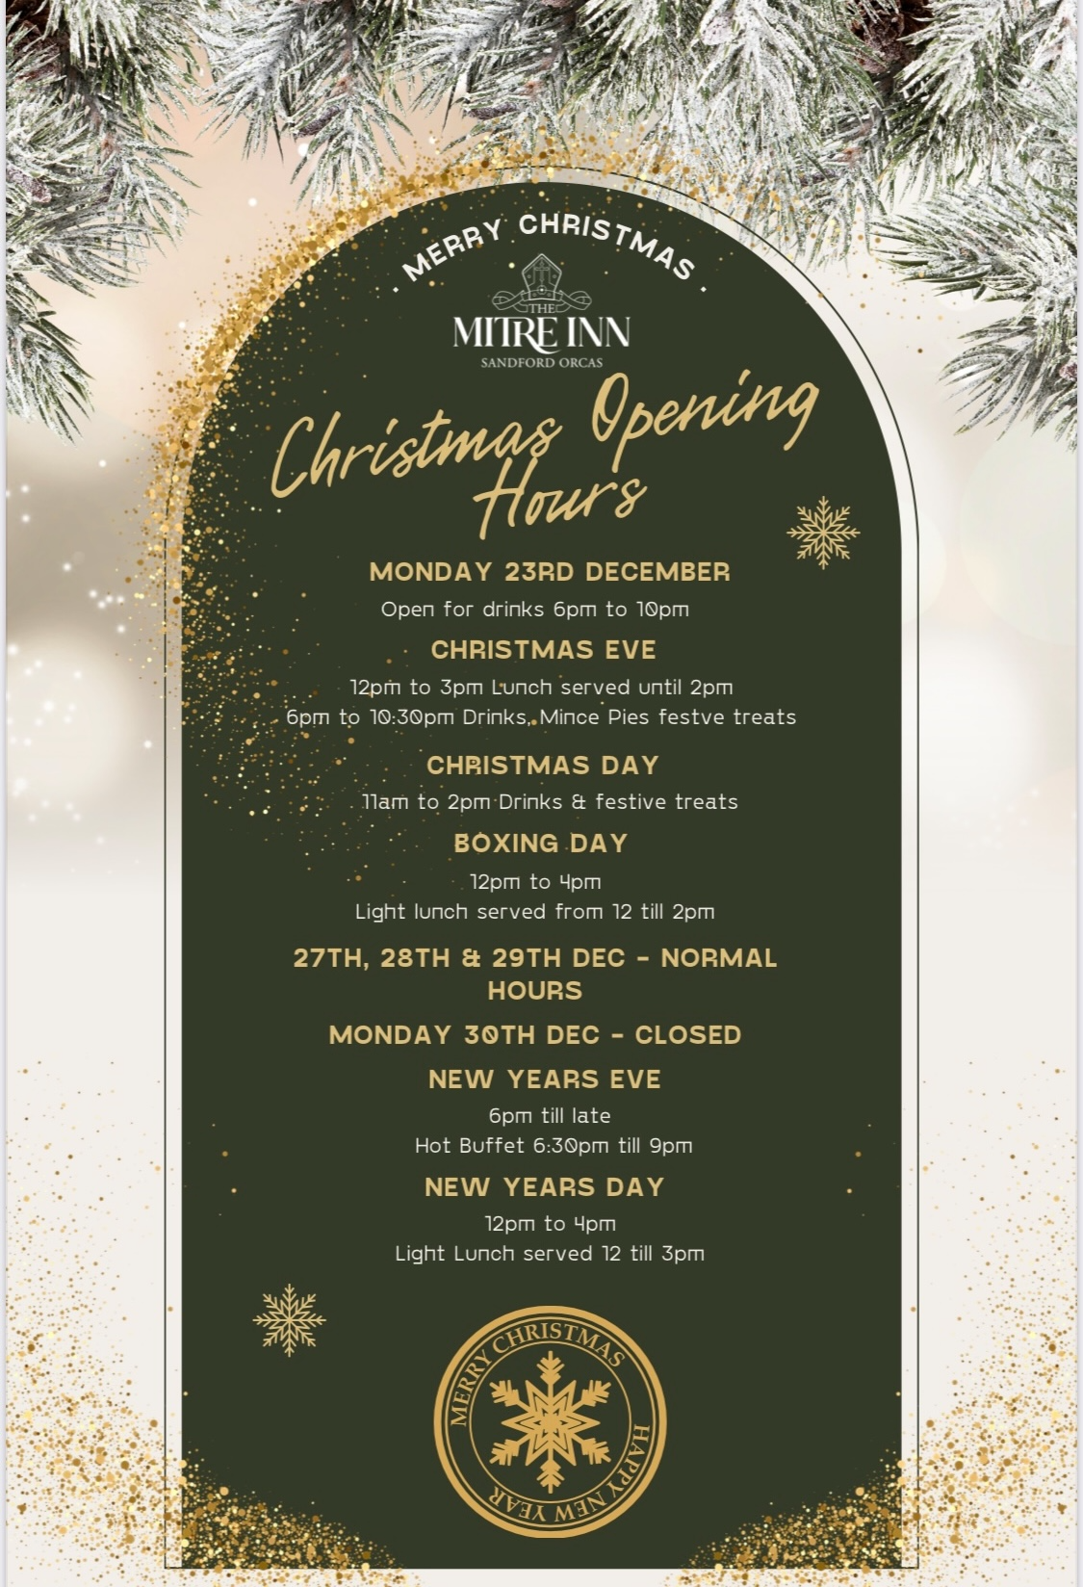
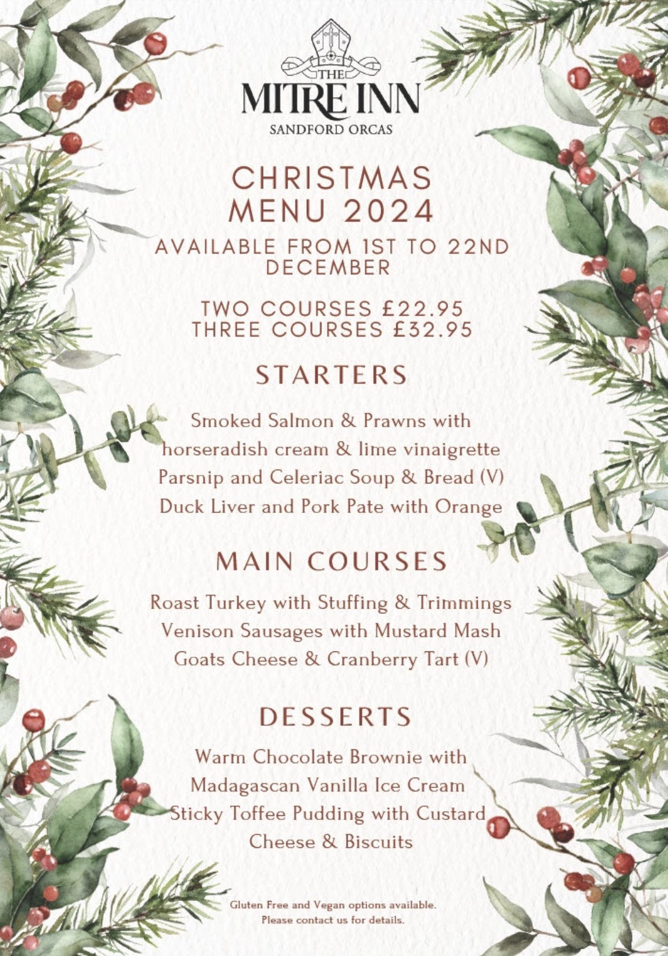
Sandford Orcas Village Community (Version 24).
Here are local suppliers who can provide home delivery or collections for basic food and health requirements. Please support, particularly, our most local businesses.

Name & Contact Info | What’s Available – To Buy or To Order | Delivery Options
The Mitre Inn, Sandford Orcas  01963 220 271, steve@mitreinn.co.uk | The menu changes weekly, with locally-sourced produce. Opening hours will be on www.mitreinn.co.uk. | The pub is open for meals.
Glenholme Herbs  Sandford Orcas, 01963 220 302  alison-redman@hotmail.com | Herbs, vegetables and vegetable plants. For the full range, see www.glenholmeherbs.co.uk | Free delivery within Sandford Orcas, or collect. Seasonal plants to order.
The Story Pig  Sandford Orcas, 07802 443 905  jameshull777@gmail.com | Tamworth pork, sausages, bacon, chutney, saffron rolls, apple buns. Also meat boxes. | Now offering pizzas – see above - along with glorious free range, rare breed Tamworth pork products - bacon rolls, pulled pork, and pork and other products. Please pre-order your pizzas on 07724 885 353: the dough is made fresh each day.
Rosanne Eskell  Higher Sandford House,  Sandford Orcas, 01963 220 275  r.eskell@hotmail.com | Sandford Orcas’ very own ‘Benchy View’ white wine, grown in Rosanne’s own vineyard. Rated “delicious” by our ex- wine merchant Rector! | Free delivery in Sandford Orcas, discuss delivery elsewhere with Rosanne when ordering.
Kim Creswell, Dip.Herb.Med.,MNIMH  By The Ford, Moorway Lane,  Sandford Orcas, 07765 654 771  www.kimcreswell.co.uk  kim@kimcreswell.co.uk  www.goldberryherbs.co.uk  kim@goldberryherbs.co.uk | Fully qualified and insured medical herbalist, trained in diagnosis, treatment and medicine making, using organically grown medicinal herbs.  Woven willow sculptures and baskets.  Willow weaving courses. | Professional, confidential and able to prescribe alongside conventional health care. Also grower of willow, maker of sculptures, baskets and other rural crafts. Workshops held and private bookings available.
Fiona Potter, Higher Orchard,  Sandford Orcas.  01963 220 773, 07708 842 553  fionapotter@live.co.uk | Bramblewood grass fed Dexter Beef. Joints, steaks, stewing steak, mince, sausages and burgers. Also Pure Apple Juice from their own trees. | Current beef stocks have expired for now – you’ve bought it all! Fiona’s apple juice remains available, and is on sale at The Story Pig.
Monique Hustinx.  07949-595632  monique.hustinx@hotmail.com | Sandford Orcas-reared, lamb. Half a Lamb: £80, Quarter of a Lamb: £40. Butchered to your requirements. | Contact Monique for delivery details.  www.ciderappletrees.co.uk
Market Town Garden  52, Cheap Street, Sherborne  07967 659638  sherbornemarketfruitandveg@aol.com | Fresh fruit and vegetables. | Contact them, or visit their shop, to discuss box sizes and delivery details.
J&M Parsons  Cheap Street, Sherborne  01935 812 071  info@parsonsbutchers.co.uk | Traditional butcher and milk, cheese, eggs. | Free delivery with orders over £10.

Useful Facebook groups: Queen Thorne Parish News and Views; Sherborne Viral Kindness

