WHAT’S ON
In The Village?
Issue 243 January 2025

A hearty welcome to 2025 to all recipients of this news sheet, from the members of Sandford Orcas Village Hall’s Management Committee. May this New Year be a good one for you.

All those who worked so hard in many different ways for our village, to put on the events that we enjoyed over Christmas in Sandford Orcas - notably the church services and the events at the Mitre Inn and The Story Pig - deserve a loud round of applause. Thank you!

The choice for the Film Night on 13th December, ‘The Man Who Invented Christmas’, was well received. It retold the story behind Charles Dickens’s classic tale ‘A Christmas Carol’.

Maggie, Richard and Marjorie ran December’s Village Café on 14th December most successfully. This month, it’s the turn of Mary Ashwin and her team. All are welcome!

Sandford Orcas’s very own carol singers, ‘The Orcas Squawkers’, delighted the village on 21st December and surprised themselves by turning out 16-strong, a big improvement from the original plan for five singers. They performed for Nigel Miskin in his care home, then sang around the village before rounding off in the Mitre Inn. They raised a worthwhile £74 for the church roof repair fund.

Two items that will affect travellers:
- Rowbarrow Hill be closed 6th - 10th January for water supply work by Wessex Water;
- Network Rail are carrying out engineering work, between 27th December and 23rd January, on the tracks between Westbury, Frome, Yeovil Junction, Yeovil Pen Mill, Salisbury, Trowbridge and Chippenham. Replacement bus services will be operating.

CONTACTS / ORGANISERS:
Website: www.sandfordorcasvillagehall.com; Email: info@sovhall.plus.com
Sandford Orcas Village Hall Committee:
Claire Arnold; Cindy Brown (Secretary); Geraldine Carter; George Lossius (Treasurer, 100 Club);
Rowlie McBeath (QTPC, Artsreach*); Robert Patterson (Billiards & Snooker; PCC);
Richard Pollard (Maintenance, Friends of SOVH); Richard Slade (Chairman).
.* Children’s events are run by Susan Yeoman and Helen Donnelly.

Village (and Outside) Organisers:
FOSOVH Friends of Sandford Orcas Village Hall I.e. anyone who wants to help, on an ad hoc basis
FPO Footpaths Officer Steve Donnelly (01963 220446)
Mitre The Mitre Inn: Steve Hooper (01963 220 271). steve@mitreinn.co.uk
HW Home Watch Allen Page (01963 220 271).
PCC Sandford Orcas PCC: Secretary: Nickie Page (07766 666552‬).‬‬‬‬‬‬‬‬‬‬‬‬‬‬‬‬‬‬‬‬‬‬‬‬‬‬‬‬‬‬‬‬‬‬‬‬‬‬‬‬‬‬‬‬‬‬‬‬‬‬‬‬‬‬‬‬‬‬‬‬‬
- Dorset Police: Sherborne Rural: PC 2777 Laura McKeeman & PCSO 6269 Mark Jones
Safer Neighbourhood Team Phone: 101, sherborneruralsnt@dorset.pnn.police.uk
QTB Queen Thorne Benefice Rector: Reverend David Bond (01935 850 201)
QTPC Queen Thorne Parish Council Parish Councillors: Jan Lowe (01963 220 490), Rowlie McBeath
(01963 220 208), Paul Phillipson (07974 348545),
Secretary: Rose Edwards (01963 220 491).
www.queenthorneparishcouncil.gov.uk
VH Village Hall: Chairman: Richard Slade (01963 220 740)
Village Hall Bookings: Cindy Brown, sandfordorcasvillagehallsec@gmail.com
Village Events Every Week:
- The Mitre Inn Opening Hours: Contact: Steve Hooper (01963 220 271, steve@mitreinn.co.uk)
  - Monday CLOSED. NEW: Saturday Breakfast Club, 9 a.m. – 11.00 a.m.
- Tuesday 6 p.m. - 10.30 p.m. (Simple Casserole / Curry from 6.30 p.m. - 8.30 p.m.).
- Wed / Thurs / Fri Sat 12.00 noon - 3 p.m. & 6 p.m. - 10.30 p.m. (Food served 12 noon - 2 p.m. & 6.30 p.m. - 8.30 p.m.).
- Sunday 12 noon - 4 p.m. (Two food sittings, 12 noon - 2 p.m. & 2.30 p.m. - 4 p.m.).
- The Story Pig Pop-Up Shop, at Lavender Keepers, in Great Pit Lane:
Open for glorious free range, pork products - bacon rolls, pulled pork and other pork products - lavender products and Charlotte’s wonderful baked goods!
- Pizza Night* on Fridays 5 p.m. - 8 p.m. ) WINTER OPENING
- Saturdays and Sundays 10 a.m. - 3 p.m. ) HOURS
* Pizzas must be pre-ordered on 07724 885 353: the dough is made fresh each day.
- Billiards & Snooker Club: Contact Robert Patterson (01963 220 455) for details.
- Table Tennis Club: Contact Richard Pollard (01963 220 893) for details.
- Bellringing: Contact John Ferdinando (01963 220 666) to learn how to ring church bells.

Saturday, 1st January 2025 Time: 10.00 a.m. for 10.30 start Mitre Inn Mitre
Annual New Year’s Day Walk
Please meet in the car park of the Mitre Inn, where lunch may be pre-ordered on 01963
220 271. For further details of the walk and about ordering lunch, please contact Helen or Steve Donnelly (01963 220 446).

Saturday, 11^{1h} January 2025. Time: 10.30 a.m. – 11.30 a.m. Village Hall SOVH
Village Café
The Village Café is a great way to catch up with local news. All proceeds go to the Village Hall. All helpers welcome - please contact Maggie Pollard. (maggiepollarde@gmail.com).

Friday, 17th January 2025. Time: 6.45 p.m. for 7.15 p.m. Village Hall
Sandford Orcas Film Night: ‘Flight Plan’ (2005) (PG-13)
Here is an enjoyable aeroplane thriller with a homeland-security flavour and a plot cheekily pinched from Hitchcock's ‘The Lady Vanishes’. Jodie Foster stars in her now familiar mom-in-peril role; she's a grieving widow on a flight to the US with her young daughter. While on board, something horrifying happens and Jodie has to convince a tense cabin staff that she is not simply delusional and that her nightmare really is happening. Our heroine comes to reject the wussy business of analysis, therapy and self-doubt - and to take some robust action.

Sunday, 26th January 2025. Time: 7.00 p.m. Mitre Inn Mitre
Quiz Night at The Mitre
Who will be the first champion quiz winners for 2025? Come along, it may be you!

And looking ahead:
Friday, 7th March 2025. Time: 7.30 p.m. Village Hall Artsreach
Nicholas Collett presents ‘The Ghost of A Smile’
Here are two of Dickens’s creepiest tales, told with a comic twist; like ‘The Woman in Black’ but funnier, and with fewer people! ‘The Queer Chair’ from The Pickwick Papers tells the story of Tom Stuart who, sheltering from a storm for the night, gets more than he bargained for from a wizened and debauched piece of furniture! Then in ‘The Ghosts of The Mail’, after a well-lubricated supper in the Old Town of Edinburgh, Jack Martin climbs
into a compound containing the derelict skeletons of old coaches and falls asleep, only to
wake as a passenger on an 18th-century mail coach with three creepy companions. An associated Meal Deal at the Mitre Inn will be available before, to be booked ahead.

Published by Sandford Orcas Village Hall Committee. Distributed free to all actual and honorary villagers.
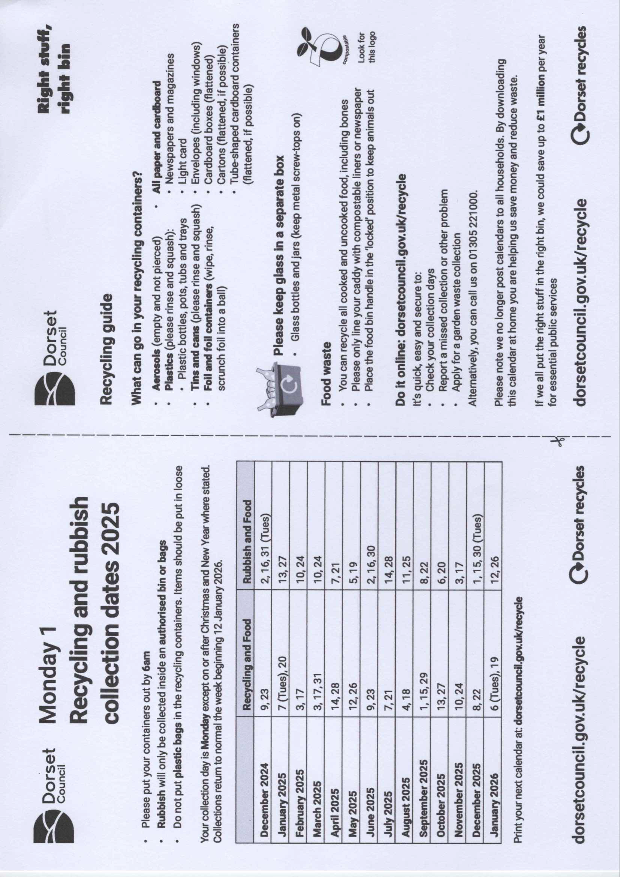
Sandford Orcas Village Community (Version 24).
Here are local suppliers who can provide home delivery or collections for basic food and health requirements. Please support, particularly, our most local businesses.

Name & Contact Info | What’s Available – To Buy or To Order | Delivery Options
The Mitre Inn, Sandford Orcas  01963 220 271, steve@mitreinn.co.uk | The menu changes weekly, with locally-sourced produce. Opening hours will be on www.mitreinn.co.uk. | The pub is open for meals.
Glenholme Herbs  Sandford Orcas, 01963 220 302  alison-redman@hotmail.com | Herbs, vegetables and vegetable plants. For the full range, see www.glenholmeherbs.co.uk | Free delivery within Sandford Orcas, or collect. Seasonal plants to order.
The Story Pig  Sandford Orcas, 07802 443 905  jameshull777@gmail.com | Tamworth pork, sausages, bacon, chutney, saffron rolls, apple buns. Also meat boxes. | Now offering pizzas – see above - along with glorious free range, rare breed Tamworth pork products - bacon rolls, pulled pork, and pork and other products. Please pre-order your pizzas on 07724 885 353: the dough is made fresh each day.
Kim Creswell, Dip.Herb.Med.,MNIMH  By The Ford, Moorway Lane,  Sandford Orcas, 07765 654 771  www.kimcreswell.co.uk  kim@kimcreswell.co.uk  www.goldberryherbs.co.uk  kim@goldberryherbs.co.uk | Fully qualified and insured medical herbalist, trained in diagnosis, treatment and medicine making, using organically grown medicinal herbs.  Woven willow sculptures and baskets.  Willow weaving courses. | Professional, confidential and able to prescribe alongside conventional health care. Also grower of willow, maker of sculptures, baskets and other rural crafts. Workshops held and private bookings available.
Fiona Potter, Higher Orchard,  Sandford Orcas.  01963 220 773, 07708 842 553  fionapotter@live.co.uk | Bramblewood grass fed Dexter Beef. Joints, steaks, stewing steak, mince, sausages and burgers. Also Pure Apple Juice from their own trees. | Current beef stocks have expired for now – you’ve bought it all! Fiona’s apple juice remains available, and is on sale at The Story Pig.
Monique Hustinx.  07949-595632  monique.hustinx@hotmail.com | Sandford Orcas-reared, lamb. Half a Lamb: £80, Quarter of a Lamb: £40. Butchered to your requirements. | Contact Monique for delivery details.  www.ciderappletrees.co.uk
Market Town Garden  52, Cheap Street, Sherborne  07967 659638  sherbornemarketfruitandveg@aol.com | Fresh fruit and vegetables. | Contact them, or visit their shop, to discuss box sizes and delivery details.
J&M Parsons  Cheap Street, Sherborne  01935 812 071  info@parsonsbutchers.co.uk | Traditional butcher and milk, cheese, eggs. | Free delivery with orders over £10.

Useful Facebook groups: Queen Thorne Parish News and Views; Sherborne Viral Kindness

