WHAT’S ON
In The Village?
Issue 246 April 2025

The Joanna and Patrick Carson and Philly Sherwin ran the Village Café on 8th March most successfully. This month, it’s the turn of Liz Rutter and Nickie Page. All are welcome!

On 7th February Nicholas Collett, aided by Gavin Robertson, gave an excellent, atmospheric demonstration of the magic art of storytelling, relating two of Charles Dickens’s lesser-known short ghost stories: ‘The Queer Chair’ and ‘The Ghosts of the Mail’. The 32-strong audience lapped up Dickens’s glorious, sparkling language.

The Film Night film on 21st February, ‘Six Minutes To Midnight’, was a gripping British thriller about the build-up to World War II.

Thank you to everyone who took part in this year’s Village Tidy on 29th March.

Two for your diaries:
- Village Hall, Thursday, 9th May. The renowned Kate Adie was Chief News Correspondent for BBC News between 1989 and 2003, during which time she reported from war zones around the world. She will be giving a talk in our Village Hall in aid of the church restoration fund. Details to follow.
- Higher Orchard, on Saturday, 2nd August. After three years of open air performances by Three Inch Fools, we return to Miracle Theatre for their bold, accessible take on Shakespeare’s ‘Twelfth Night’ - his joyous, chaotic comedy, in which love knows no boundaries! Thank you to the Potters for hosting at Higher Orchard.

Final reminder: the clocks ‘Sprang Forward’ by one hour at 1 a.m. on Sunday, 30th March.

CONTACTS / ORGANISERS:
Website: www.sandfordorcasvillagehall.com; Email: info@sovhall.plus.com
Sandford Orcas Village Hall Committee:
Claire Arnold; Cindy Brown (Secretary); Geraldine Carter; George Lossius (Treasurer, 100 Club);
Rowlie McBeath (QTPC, Artsreach*); Robert Patterson (Billiards & Snooker; PCC);
Richard Pollard (Maintenance, Friends of SOVH); Richard Slade (Chairman).
.* Children’s events are run by Susan Yeoman and Helen Donnelly.

Village (and Outside) Organisers:
FOSOVH Friends of Sandford Orcas Village Hall I.e. anyone who wants to help, on an ad hoc basis
FPO Footpaths Officer Steve Donnelly (01963 220446)
Mitre The Mitre Inn: Steve Hooper (01963 220 271). steve@mitreinn.co.uk
HW Home Watch Allen Page (01963 220 271).
PCC Sandford Orcas PCC: Secretary: Nickie Page (07766 666552‬).‬‬‬‬‬‬‬‬‬‬‬‬‬‬‬‬‬‬‬‬‬‬‬‬‬‬‬‬‬‬‬‬‬‬‬‬‬‬‬‬‬‬‬‬‬‬‬‬‬‬‬‬‬‬‬‬‬‬‬‬‬‬‬‬‬‬‬‬‬‬‬‬‬‬‬‬‬‬‬‬‬
- Dorset Police: Sherborne Rural: PC 2777 Laura McKeeman & PCSO 6269 Mark Jones
Safer Neighbourhood Team Phone: 101, sherborneruralsnt@dorset.pnn.police.uk
QTB Queen Thorne Benefice Rector: Reverend David Bond (01935 850 201)
QTPC Queen Thorne Parish Council Parish Councillors: Jan Lowe (01963 220 490), Rowlie McBeath
(01963 220 208), Paul Phillipson (07974 348545),
Secretary: Rose Edwards (01963 220 491).
www.queenthorneparishcouncil.gov.uk
VH Village Hall: Chairman: Richard Slade (01963 220 740)
Village Hall Bookings: Cindy Brown, sandfordorcasvillagehallsec@gmail.com
Village Events Every Week:
- The Mitre Inn Opening Hours: Contact: Steve Hooper (01963 220 271, steve@mitreinn.co.uk)
  - Monday CLOSED. Saturday Breakfast Club, 9 a.m. – 11.00 a.m.
- Tuesday 6 p.m. - 10.30 p.m. (Simple Casserole / Curry from 6.30 p.m. - 8.30 p.m.).
- Wed / Thurs / Fri Sat 12.00 noon - 3 p.m. & 6 p.m. - 10.30 p.m. (Food served 12 noon - 2 p.m. & 6.30 p.m. - 8.30 p.m.).
- Sunday 12 noon - 4 p.m. (Two food sittings, 12 noon - 2 p.m. & 2.30 p.m. - 4 p.m.).
- The Wilde Pig Pop-Up Shop, at Lavender Keepers, in Great Pit Lane:
STOP PRESS: The Story Pig is now The Wilde Pig, reflecting their evolving journey.
Open for glorious free range, pork products - bacon rolls, pulled pork and other pork products - lavender products and Charlotte’s wonderful baked goods!
- Pizza Night* on Fridays 5 p.m. - 8 p.m.
- Café & Shop every Weekend (+ Roast Lunch on Sundays) 10 a.m. - 3 p.m.
* Pizzas must be pre-ordered on 07724 885 353: the dough is made fresh each day.
- Billiards & Snooker Club: Contact Robert Patterson (07983 729602‬) for details.‬‬‬‬‬‬‬‬‬‬‬‬‬
- Table Tennis Club: Contact Richard Pollard (01963 220 893) for details.
- Bellringing: Contact John Ferdinando (01963 220 666) to learn how to ring church bells.

Friday, 4th April 2025. Time: 12.30 p.m. – 2.00 p.m. Village Hall PCC
Lent Lunch
﻿This is the last of this year’s Lent Lunches. Those in March have been well-attended and enjoyed by all. Everyone is welcome - please just turn up to Sandford Orcas Village Hall for a simple and delicious light lunch. Enjoy delicious soup, bread, cheese and fruit, and tea or coffee, payment by donation. All proceeds in aid of the church restoration fund.

Saturday, 12th April 2025. Time: 10.30 a.m. – 11.00 a.m. Village Hall SOVH
Village Café
The Village Café is a great way to catch up with local news. All proceeds go to the Village Hall. All helpers welcome - please contact Maggie Pollard. (maggiepollarde@gmail.com).

Saturday, 12th April 2024. Time: 11.00 a.m. Village Hall QTPC Sandford Orcas’ Annual Village Meeting
Contact: Claire Arnold (Chairman) (07968 960618). Starting straight after the Village Café, here’s your chance to raise issues about village and other concerns, and to hear what’s planned for the coming year.

Friday, 18th April 2025. Time: 6.45 p.m. for 7.15 p.m. Village Hall SOVH
Sandford Orcas Film Night: ‘Difret ‘(2014) (PG-13)
The compelling ‘Difret’ is a small film with a lot on its mind. Authentic and affecting, this drama about fighting against the Ethiopian tradition of abducting young girls into marriage is potent enough to be that country’s official Academy Award submission. Based on an actual incendiary legal case that was a sensation in Ethiopia a decade before, ‘Difret’ provides a dramatic yet nuanced window into a culture we almost never see.

Sunday, 20th April 2025. Time: 10.00 a.m. - 3 p.m. Sherborne Town Centre Sherborne Market – the First One in 2025

Sunday, 20th April 2025. Time: 7.00 p.m. Mitre Inn Mitre Easter Sunday

Sunday, 27th April 2025. Time: 7.00 p.m. Mitre Inn Mitre Quiz Night at The Mitre
Who will win this month? Come along, it could be you!

Published by Sandford Orcas Village Hall Committee. Distributed free to all actual and honorary villagers.
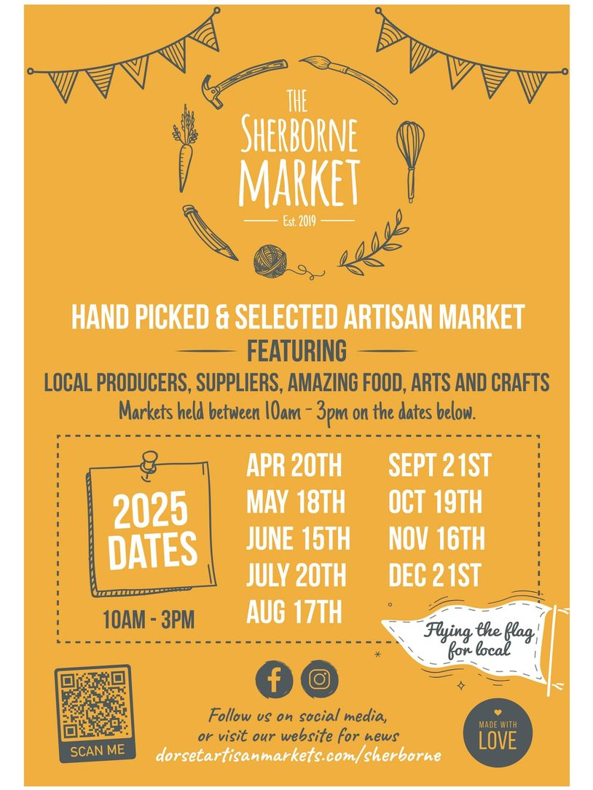

Live at Sandford Orcas Village Hall, DT9 4RX
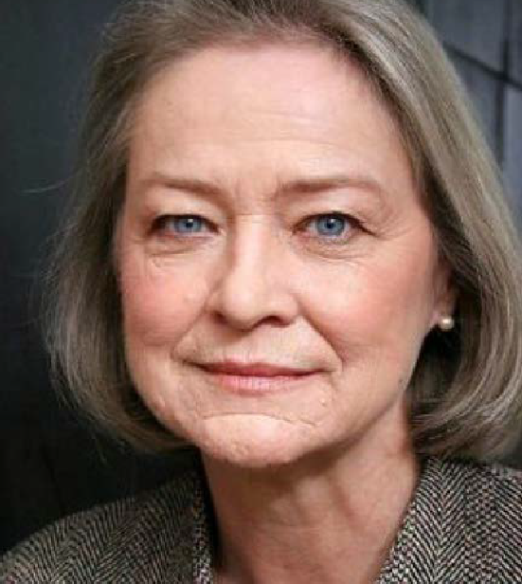
Friday 09th May 2025
7.00 for 7.30 start

An Evening with Kate Adie
Join us for a captivating evening with Kate Adie OBE, one of the world’s most renowned war correspondents. With a career that has taken her to the front lines of global conflicts, Kate has witnessed history unfold in some of the most dangerous places on Earth. Beyond the battlefield, she is also a celebrated author and has an extraordinary personal journey, including the moving search for her birth mother. With her trademark wit, keen insight, and sharp storytelling, Kate is a natural raconteur who never fails to engage and inspire.

Following the overwhelming success of her recent sold-out event in aid of Dorchester Hospital, we are thrilled to welcome her to Sandford Orcas for an unforgettable evening.

Pimms Cocktail, Bar available, all welcome.

Tickets £12.50, available from The Mitre (01963 220271), Rowlie (07734 088958) or Geraldine (07770 721201)

Don’t miss this rare opportunity to hear from a true legend of journalism!
Sandford Orcas Village Community (Version 26).
Here are local suppliers who can provide basic food and health requirements and services. Please support, particularly, our most local businesses.

Name & Contact Info | What’s Available – To Buy or To Order | Delivery Options
The Mitre Inn, Sandford Orcas  01963 220 271, steve@mitreinn.co.uk | The menu changes weekly, with locally-sourced produce. Opening hours will be on www.mitreinn.co.uk. | The pub is open for meals.
Glenholme Herbs  Sandford Orcas, 01963 220 302  alison-redman@hotmail.com | Herbs, vegetables and vegetable plants. For the full range, see www.glenholmeherbs.co.uk | Free delivery within Sandford Orcas, or collect. Seasonal plants to order.
The Wilde Pig (ex- The Story Pig)  Sandford Orcas, 07802 443 905  jameshull777@gmail.com | Tamworth pork, sausages, bacon, chutney, saffron rolls, apple buns. Also meat boxes. | Now offering pizzas – see above - along with glorious free range, rare breed Tamworth pork products - bacon rolls, pulled pork, and pork and other products. Please pre-order your pizzas on 07724 885 353: the dough is made fresh each day.
Kim Creswell, Dip.Herb.Med.,MNIMH  By The Ford, Moorway Lane,  Sandford Orcas, 07765 654 771  www.kimcreswell.co.uk  kim@kimcreswell.co.uk  www.goldberryherbs.co.uk  kim@goldberryherbs.co.uk | Fully qualified and insured medical herbalist, trained in diagnosis, treatment and medicine making, using organically grown medicinal herbs.  Woven willow sculptures and baskets.  Willow weaving courses. | Professional, confidential and able to prescribe alongside conventional health care. Also grower of willow, maker of sculptures, baskets and other rural crafts. Workshops held and private bookings available.
Fiona Potter, Higher Orchard,  Sandford Orcas.  01963 220 773, 07708 842 553  fionapotter@live.co.uk | Bramblewood grass fed Dexter Beef. Joints, steaks, stewing steak, mince, sausages and burgers. Also Pure Apple Juice from their own trees. | Fiona has a large freezer bursting with her delicious beef. Please ring her to order some!
Monique Hustinx.  07949-595632  monique.hustinx@hotmail.com | Sandford Orcas-reared, lamb. Half a Lamb: £80, Quarter of a Lamb: £40. Butchered to your requirements. | Contact Monique for delivery details.  www.ciderappletrees.co.uk
Penmore Repairs  Ed Page – Handyman  Kimberside, Penmore Road, Sandford Orcas.  07342 670769  edpageworks@gmail.com | Repairs: garden, fencing, clearance, computer help, sheds, garden dog proofing, … | Contact Ed.
Market Town Garden  52, Cheap Street, Sherborne  07967 659638  sherbornemarketfruitandveg@aol.com | Fresh fruit and vegetables. | Contact them, or visit their shop, to discuss box sizes and delivery details.
J&M Parsons  Cheap Street, Sherborne  01935 812 071  info@parsonsbutchers.co.uk | Traditional butcher and milk, cheese, eggs. | Free delivery with orders over £10.

Useful Facebook groups: Queen Thorne Parish News and Views; Sherborne Viral Kindness

