WHAT’S ON
In The Village?
Issue 252 October 2025

Thank you to the many villagers who sponsored this year’s Ride + Stride on 13th September, which raised money for Dorset Historic Churches Trust. Sandford Orcas parish can expect to benefit by almost £300 as a result, which will go towards the church roof restoration fund.

Thank you to Maggie and Jim Dooley, for running the Village Café on 13th September most successfully. This month, it’s the turn of Geraldine and Cecil Carter. All are welcome!

A lovely Harvest Festival service and a delicious Harvest Lunch - many thanks to the organisers and to the 40-odd who took part. They raised a remarkable £621 for church funds!

Sandford Orcas Film Night returns on 19th October. David and Margorie Pearson, who have moved to Sherborne after running the Film Night very successfully – for which we thank them. Roger and Cindy Brown are now in charge. Their first choice is ‘Ammonite’ – see over.

John Ferdinando has stepped back from being Tower Captain at St Nicholas’s church in Sandford Orcas. Helen Donnelly and Richard Pollard will take over and share the position. They will start ringing for beginners on Monday nights starting in October, led by a qualified instructor. Please contact them at helen-9@hotmail.co.uk or richardpollardj@gmail.com.

Good news for the Mitre Inn! As for any pub, the change of ownership resulted in its non-appearance in CAMRA’s The Good Beer Guide last year. Now the Mitre Inn is back where it belongs. The Good Beer Guide praises it as a ‘classic traditional free house’, its ‘good quality food’, and its new, well-equipped terrace garden. The brand-new kitchen is now in operation.

British Summer Time ends on Sunday, 28th October. The clocks go back 1 hour at 2.00 a.m.

CONTACTS / ORGANISERS:
Website: www.sandfordorcasvillagehall.com; Email: info@sovhall.plus.com
Sandford Orcas Village Hall Committee:
Claire Arnold; Cindy Brown (Secretary); Geraldine Carter; George Lossius (Treasurer, 100 Club);
Rowlie McBeath (QTPC, Artsreach*); Robert Patterson (Billiards & Snooker; PCC);
Richard Pollard (Maintenance, Friends of SOVH); Richard Slade (Chairman).
.* Children’s events are run by Susan Yeoman and Helen Donnelly.

Village (and Outside) Organisers:
FOSOVH Friends of Sandford Orcas Village Hall I.e. anyone who wants to help, on an ad hoc basis
FPO Footpaths Officer Steve Donnelly (01963 220446)
Mitre The Mitre Inn: Steve Hooper (01963 220 271). steve@mitreinn.co.uk
NW Neighbourhood Watch Steve Hooper (01963 220 271). steve@mitreinn.co.uk
PCC Sandford Orcas PCC: Secretary: Nickie Page (07766 666552‬).‬‬‬‬‬‬‬‬‬‬‬‬‬‬‬‬‬‬‬‬‬‬‬‬‬‬‬‬‬‬‬‬‬‬‬‬‬‬‬‬‬‬‬‬‬‬‬‬‬‬‬‬‬‬‬‬‬‬‬‬‬‬‬‬‬‬‬‬‬‬‬‬‬‬‬‬‬‬‬‬‬‬‬‬‬‬‬‬‬‬‬‬‬‬‬‬‬‬‬‬‬‬‬‬‬‬‬
- Dorset Police: Sherborne Rural: PCSO 6269 Mark Jones
Safer Neighbourhood Team Phone: 101, sherborneruralsnt@dorset.pnn.police.uk
QTB Queen Thorne Benefice Rector: Reverend David Bond (01935 850 201)
QTPC Queen Thorne Parish Council Parish Councillors: Jan Lowe (01963 220 490), Rowlie McBeath
(01963 220 208), Paul Phillipson (07974 348545),
Clerk: Rose Edwards (01963 220 491).
www.queenthorneparishcouncil.gov.uk
VH Village Hall: Chairman: Richard Slade (01963 220 740)
Village Hall Bookings: Cindy Brown, sandfordorcasvillagehallsec@gmail.com
Village Events Every Week:
- The Mitre Inn Opening Hours: Contact: Steve Hooper (01963 220 271, steve@mitreinn.co.uk)
  - Sunday 12 noon - 4 p.m. Monday CLOSED. Tuesday 6 p.m. - 10.30 p.m.
- Wed / Thurs / Fri / Sat 12.00 noon - 3 p.m. & 6 p.m. - 10.30 p.m..
- The Mitre Inn’s kitchen is being totally refurbished. Until early October, pizzas will be available at lunchtime on Tuesdays to Sundays, and in the evenings on Tuesdays to Saturdays, at the top of the terraced garden.
- The Wilde Story Company Pop-Up Shop, at Lavender Keepers, in Great Pit Lane:
Open for glorious lavender and other local products as well as free range, pork products - bacon rolls, pulled pork and other porky things - and Charlotte’s wonderful baked goods!
- Pizza Night* on Fridays 5 p.m. - 8 p.m.
- Café & Shop every Weekend (+ Roast Lunch on Sundays) 10 a.m. - 3 p.m.
* Pizzas must be pre-ordered on 07724 885 353; the dough is made fresh each day.
- Billiards & Snooker Club: Contact Robert Patterson (07983 729602‬) for details.‬‬‬‬‬‬‬‬‬‬‬‬‬‬‬‬‬‬‬‬‬‬‬‬‬‬‬‬‬‬‬‬‬‬‬‬‬‬‬
- Table Tennis Club: Contact Richard Pollard (01963 220 893) for details.
- Bellringing: Contact Helen Donnelly or Richard Pollard (07990 516930‬ or 01963 220893).‬‬

Saturday, 11th October 2025. Time: 10.30 a.m. – 12.00 a.m. Village Hall SOVH
Village Café
The Village Café is a great way to catch up with local news. All proceeds go to the Village Hall. All helpers welcome - please contact Maggie Pollard. (maggiepollarde@gmail.com).

Friday, 17th October 2025. Time: 10.30 p.m.for 7.30 p.m. Village Hall SOVH
Sandford Orcas Film Night presents ‘Anatomy of A Fall’ (2023, R)
The new season starts here! For the past year, Sandra, her husband Samuel, and their eleven-year-old son Daniel have lived a secluded life in a remote town in the French Alps. When Samuel is found dead in the snow below their chalet, the police question whether he was murdered or committed suicide. Samuel’s suspicious death is presumed murder, and Sandra becomes the main suspect. What follows is not just an investigation into the circumstances of Samuel’s death but an unsettling psychological journey into the depths of Sandra’s and Samuel’s conflicted relationship.

Sunday, 19th October 2025. Time: 10.00 a.m. - 3 p.m. Sherborne Town Centre Sherborne Market
The Sherborne Market, held on the third Sunday of each month, features 170 stalls: local producers, suppliers selling amazing hand-picked amazing local artisan food, arts and crafts, in Cheap Street, Abbey Road, Half Moon Street, Digby Road & Pageant Gardens.

Wednesday, 29th October 2025. Time: 10.00 a.m. - 3 p.m. Artsreach
Fideri Fidera present ‘Franky’
Prof Frankenstein feels lonely. She has no friends and the local villagers are afraid of her. The professor thinks a baby might change things and so, one stormy night with a flash of lightning and the help of her robot Igor, she creates... FRANKY! Although Franky is not quite what the Prof imagined, he sets off on an adventure to win the hearts of the grumpy villagers. Expect a fun-filled story with songs, a riotous hook-a-duck game, and the chance to learn the hottest new dance craze ‘The Franky Walk!’ For all ages, recommended 3+ and all adults.

After the show, why not join the cast and take part in a Franky Drama Workshop, with creative activities and games inspired by the themes of the play. Places are limited. Booking essential.
Tickets: £6 adults, £4 children, £24 family (max 2 adults) for EACH of ‘Franky’ and the Drama Workshop. Available from Susan Yeoman (07837 812468), Helen Donnelly (07990 516930) or the Mitre Inn (01963 220 271).

Published by Sandford Orcas Village Hall Committee. Distributed free to all actual and honorary villagers.
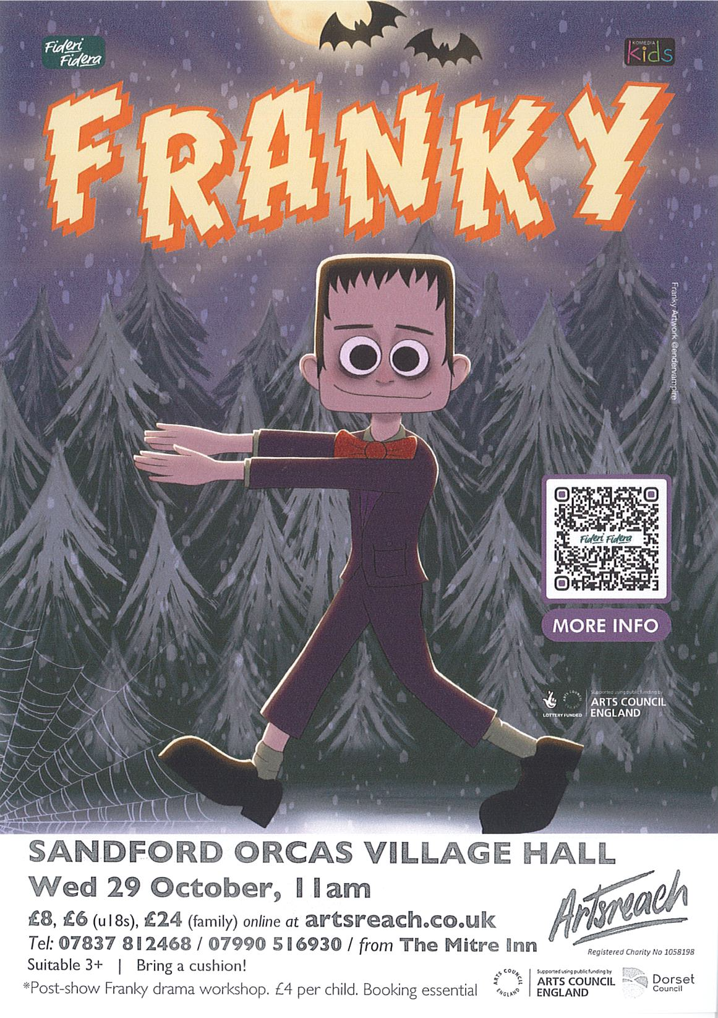

Sandford Orcas Village Community (Version 26).
Here are local suppliers who can provide basic food and health requirements and services. Please support, particularly, our most local businesses.

Name & Contact Info | What’s Available – To Buy or To Order | Delivery Options
The Mitre Inn, Sandford Orcas  01963 220 271, steve@mitreinn.co.uk | The menu changes weekly, with locally-sourced produce. Opening hours will be on www.mitreinn.co.uk. | The pub is open for meals.
Glenholme Herbs  Sandford Orcas, 01963 220 302  alison-redman@hotmail.com | Herbs, vegetables and vegetable plants. For the full range, see www.glenholmeherbs.co.uk | Free delivery within Sandford Orcas, or collect. Seasonal plants to order.
The Wilde Pig (ex- The Story Pig)  Sandford Orcas, 07802 443 905  jameshull777@gmail.com | Tamworth pork, sausages, bacon, chutney, saffron rolls, apple buns. Also meat boxes. | Now offering pizzas – see above - along with glorious free range, rare breed Tamworth pork products - bacon rolls, pulled pork, and pork and other products. Please pre-order your pizzas on 07724 885 353: the dough is made fresh each day.
Kim Creswell, Dip.Herb.Med.,MNIMH  By The Ford, Moorway Lane,  Sandford Orcas, 07765 654 771  www.kimcreswell.co.uk  kim@kimcreswell.co.uk  www.goldberryherbs.co.uk  kim@goldberryherbs.co.uk | Fully qualified and insured medical herbalist, trained in diagnosis, treatment and medicine making, using organically grown medicinal herbs.  Woven willow sculptures and baskets.  Willow weaving courses. | Professional, confidential and able to prescribe alongside conventional health care. Also grower of willow, maker of sculptures, baskets and other rural crafts. Workshops held and private bookings available.
Fiona Potter, Higher Orchard,  Sandford Orcas.  01963 220 773, 07708 842 553  fionapotter@live.co.uk | Bramblewood grass fed Dexter Beef. Joints, steaks, stewing steak, mince, sausages and burgers. Also Pure Apple Juice from their own trees. | Fiona has a large freezer bursting with her delicious beef. Please ring her to order some!
Monique Hustinx.  07949-595632  monique.hustinx@hotmail.com | Sandford Orcas-reared, lamb. Half a Lamb: £80, Quarter of a Lamb: £40. Butchered to your requirements. | Contact Monique for delivery details.  www.ciderappletrees.co.uk
Penmore Repairs  Ed Page – Handyman  Kimberside, Penmore Road, Sandford Orcas.  07342 670769  edpageworks@gmail.com | Repairs: garden, fencing, clearance, computer help, sheds, garden dog proofing, … | Contact Ed.
Market Town Garden  52, Cheap Street, Sherborne  07967 659638  sherbornemarketfruitandveg@aol.com | Fresh fruit and vegetables. | Contact them, or visit their shop, to discuss box sizes and delivery details.
J&M Parsons  Cheap Street, Sherborne  01935 812 071  info@parsonsbutchers.co.uk | Traditional butcher and milk, cheese, eggs. | Free delivery with orders over £10.

Useful Facebook groups: Queen Thorne Parish News and Views; Sherborne Viral Kindness

